

Arab Academy for Science, Technology, and Maritime Transport
College of Computing and Information Technology
Alexandria

Smart Home Application
Graduation Project

By:
Mohamed Tarek Elsaid 20102053
Abdelrahman Kamal 20100101
Mohamed Amin Sewilam 20109043
Abdallah Mohamed Hamed 20109594
Ziad Hamed 20100373
College of Computing and Information Technology, AASTMT, 2024

Supervised by:
Dr/ Emad Raouf

Alexandria, 2024
Abstract
In the realm of Internet of Things (IoT) and smart home technologies, the proposed application leverages interconnected devices to enhance home automation and user convenience. The application integrates Wi-Fi connectivity, MQTT protocol, and sensor data processing to facilitate seamless control and monitoring of home environments.
Acknowledgement
We would like to thank our supervisor, Dr. Emad Raouf, for the patient guidance, encouragement and advice he has provided throughout our time as his students. We have been extremely lucky to have a supervisor who cared so much about our work, and who responded to our questions and queries so promptly.

Contents
Chapter 1 5
1.1 introduction 5
1.1.1 General Idea 5
1.1.2 IOT 5
1.1.2 Arduino Nano iot 33 6
1.1.4 Sensors 6
1.2 Motivation 6
1.3 Problem Statement 7
1.4 Solution 7
1.5 Objectives 9
1.6 Constraints 10
1.7 Standards 10
1.8 Feasibility Study and Business Canvas 11
Chapter 2 13
2.1 Background 13
2.2 Similar Systems 14
2.3 Requirements and Functionalities 17
2.3.1 Functional Requirements 17
2.3.2 Non-Functional Requirements 18
Chapter 3 Design 19
3.1 Mind Map 21
3.2 UML Diagrams 23
3.2.1 DFD 0 23
23
3.2.2 DFD 1 24
3.2.3 DFD 2 25
3.3 Use Case Diagram 26
3.4 Activity Diagram 28
3.5 Class Diagram 29
3.6 Sequence Diagram 31
3.7 State Chart Diagram 33
3.8 Technologies and Tools Used 34
3.8.1 Front End Technology 34
3.8.2 Back End Technology: 37
3.8.3 Machine Learning Models and Algorithms 38
3.9 Prototype 42
3.10 Implementation Plan 57
Chapter 4 Implementation 58
4.1 Implementation Environment 58
4.1.1 Frontend 58
4.1.2 Dart 59
4.1.3 Backend 59
4.2 List of Implementations 60
4.2.1 Frontend 60
4.2.2 Architecture 60
64
67
4.2.3 Security and Privacy 71
Chapter 5 Testing 72
Chapter 6 Conclusion and Future Work 82
6.1 Conclusion 82
6.2 Future Work 83
Chapter 7 Appendix A 86
7.1 Sample User Flow 86
7.2 Code 88
7.2.1 Dart 88
7.2.2 Python 88
7.2.3 C 88
Chapter 8 Bibliography 89

Chapter 1

introduction

General Idea
The advent of smart home technology has revolutionized the way we interact with our living spaces. The concept of a connected and automated home has become a reality. In line with this trend, the proposed application aims to develop a smart home application that controls the lighting system using face recognition and hand gestures, providing users with a convenient and personalized lighting experience. This typically would help save time, effort, and money by providing an app that can manage the whole process of turning on/off lights and devices, changing light colors, controlling light intensity, and turning off devices that are not in use without human interaction. Additionally, the application will feature a feed screen displaying real-time temperature and humidity in the home, enabling users to monitor their environment.

1.1.2 IOT
The Internet of Things (IoT) refers to a network of physical devices, vehicles, appliances, and other physical objects that are embedded with sensors, software, and network connectivity that allows them to collect and share data. These devices — also known as “smart objects” — can range from simple “smart home” devices like smart thermostats to wearables like smartwatches and RFID-enabled clothing, to complex industrial machinery and transportation systems. Technologists are even envisioning entire “smart cities” predicated on IoT technologies.
Our application interacts with physical devices, such as lights controlled by an Arduino Nano iot 33. These devices become part of the IoT ecosystem, allowing users to manage and control them remotely through the application.
IoT enables users to remotely control and monitor their home devices. Users can turn lights on or off, adjust colors, and manage other preferences using the Flutter app, which communicates with the Arduino board.
IoT devices collect and transmit data to the application. For example, the Arduino may provide information about the current state of the lights, enabling real-time monitoring. Additionally, sensors connected to the Arduino can gather environmental data like humidity and temperature.
IoT facilitates automation in our application. For instance, the application can analyze user behavior, learn from their preferences, and suggest optimal turn-off times for lights based on historical data collected from IoT devices.

Arduino Nano iot 33
The Arduino Nano 33 IoT is a compact microcontroller board designed for IoT applications, featuring a SAMD21 Cortex®-M0+ 32-bit ARM MCU, and offering both Wi-Fi and Bluetooth connectivity through the u-blox NINA-W10 module. It operates at 3.3V, with 14 digital I/O pins, 8 analog inputs, and a 10-bit DAC. The board includes 256KB of Flash memory, 32KB of SRAM, and runs at a clock speed of 48 MHz. It also features a built-in RGB LED and an ECC608 crypto chip for secure communication. Measuring 45 mm x 18 mm, it can be powered via Micro-USB or an external source. Ideal for smart home devices, wearables, and secure data transmission projects, the Nano 33 IoT combines power and connectivity in a small form factor, making it perfect for both prototyping and embedding in final products.

1.1.4 Sensors
The DHT22 is a popular and highly accurate digital sensor for measuring temperature and humidity. It operates with a temperature range of -40 to 80°C and a humidity range of 0-100% RH, boasting an accuracy of ±0.5°C and ±2-5% RH, respectively. The sensor outputs data as a digital signal, making it easy to interface with microcontrollers like Arduino. It features a 4-pin interface: VCC, GND, Data, and a not-connected pin, typically powered by a 3.3V or 5V supply. The DHT22 has a sampling rate of 0.5 Hz (one reading every two seconds) and includes a built-in pull-up resistor for the data line. Its compact size and low power consumption make it suitable for a wide range of applications, including HVAC systems, weather stations, and environmental monitoring. Enclosed in a durable plastic casing, the DHT22 is reliable for both indoor and outdoor use, providing precise measurements in various conditions.

Motivation
Traditional home lighting systems often rely on manual switches or remote controls, which can be inconvenient and outdated in today's fast-paced world. Smart home technology offers a solution by integrating lighting control with advanced features and automation. Face recognition and automated control are emerging technologies that have gained significant attention due to their potential to enhance user experience and convenience within smart homes.

Problem Statement
Despite the advancements in smart home technology, there remains a need for a lighting control system that is both user-friendly and efficient, and that integrates seamlessly with face recognition and environmental monitoring features. Many existing solutions lack a comprehensive approach, focusing on lighting control, and may not provide real-time data on temperature and humidity or keep track of usage times of lights.

1.4 Solution
This project aims to address a complex issue by breaking it down into several key components:
1) User-Centric Lighting Control:
Current smart home lighting systems often require manual app-based control or voice commands. This project seeks to create a more personalized and seamless lighting control system. This involves designing a reliable and efficient face recognition system that identifies users within a reasonable time frame. Additionally, a user preference database will be developed to store lighting settings and automatically adjust to a user's preferred lighting conditions.
2) Automated Control for Lighting:
The project will explore the use of buttons as an alternative control method.
3) Integration and Usability:
To ensure ease of use, a user-friendly and intuitive mobile application will be developed for controlling the lighting system and configuring preferences. The project will also address potential challenges related to lighting system compatibility with the proposed control methods.
4) Environmental Monitoring:
Incorporating a real-time temperature and humidity monitoring system into the application will help users maintain a comfortable and healthy living environment. It's important that the system ensures data accuracy and provides reliable feedback to users.
5) Energy Saving:
The system allows users to set their daily turn-off time, automatically generating an estimated date to turn off lights when not in use or send it to the administration of the compounds or institutions to get highlights to benefit from it or to use it for different purposes.

We can structure the problem in FIVE Ws:
Who:
Target users: Homeowners and residents looking to enhance the convenience, energy efficiency, and security of their homes.
Potential stakeholders: Developers, manufacturers, and technology enthusiasts interested in creating and implementing innovative smart home solutions.
What:
Develop a smart home application for controlling the lighting system.
Implement face recognition to provide users with easier and safer and more efficient sign-in.
Provide personalized experience for lighting control and an efficient way of manual control.
Integrate real-time temperature and humidity monitoring.
Ensure security and privacy in data handling.
Where:
The project can be implemented in various residential settings, such as houses, apartments, and condominiums.
Geographical location may vary, but the technology can be applicable globally.
When:
The project is a graduation project, with a specified timeframe for completion and demonstration.
Once developed and tested successfully, it can be deployed for use in homes, depending on the project's future development and deployment plans.
This idea has been in existence for many years, but its current focus is primarily on the present day.
Why:
To enhance the quality of life by providing a more intuitive, personalized, and energy-efficient lighting control system.
To contribute to SDGs, particularly:
SDG 7: Affordable and Clean Energy: By promoting energy-efficient lighting control.
SDG 9: Industry, Innovation, and Infrastructure: By developing innovative smart home technology.
SDG 11: Sustainable Cities and Communities: By improving the sustainability of urban living through smart home solutions.
SDG 13: Climate Action: By promoting energy efficiency and reducing energy consumption.
SDG 17: Partnerships for the Goals: By potentially partnering with technology companies for the development and deployment of the project.

In conclusion, the smart home application project focused on lighting control through face recognition, preference management, and environmental monitoring represents an innovative and holistic approach to enhancing the quality of life while aligning with several Sustainable Development Goals (SDGs). By offering personalized and accessible lighting control, promoting energy efficiency, and ensuring security and privacy, this project contributes to a more sustainable and comfortable future for homeowners. It embraces the spirit of technological innovation, improving the way we interact with our living spaces and promoting sustainable living practices.

1.5 Objectives
1- Create a user-friendly and secure registration process, allowing users to easily sign up using a username/password and face recognition.
2-Enhance the onboarding experience by guiding users through the profile customization to set up their lighting preferences effortlessly.
3-Develop an intuitive and visually appealing interface for users to effortlessly control lighting settings manually.
4-Implement a personalized lighting experience, allowing users to customize colors, intensity, and ambiance based on their preferences.
5-Implement a scheduling feature that adapts to users' routines, optimizing the smart home experience based on their daily activities.
6-Provide users with real-time information on their home environment, including humidity and temperature.
7-Enhance user awareness by integrating weather data, helping them make informed decisions about their living spaces.
8-Prioritize user data security by implementing robust authentication measures and secure data transmission.

1.6 Constraints
The application will only work in Egypt.
The application doesn’t support other electronic devices.
Hardware Limitations: The capabilities and limitations of the Arduino Nano or any other hardware components used in the project can be a constraint. For example, memory limitations, processing power, and the number of available I/O pins on the Arduino Nano.
Data Security and Privacy Constraints: Implementing robust security measures within the application to ensure the protection of user data and privacy can be a constraint. Compliance with data protection regulations and industry standards may also be a consideration.

1.7 Standards
Requirements Specification Standards:
IEEE Std 830-1998: IEEE Recommended Practice for Software Requirements Specifications.
Design Standards:
IEEE Std 1016-2009: IEEE Standard for Information Technology - Systems Design - Software Design Descriptions.
Software Process Models:
Agile Development: Following agile principles for iterative and incremental development.
Coding Standards:
Google Flutter Style Guide: A style guide for Flutter development, providing conventions for code structure and formatting.
Testing Standards:
IEEE Std 829-2008: IEEE Standard for Software and System Test Documentation.
API Design Standards:
RESTful API Standards: Adhering to best practices for designing RESTful APIs.

1.8 Feasibility Study and Business Canvas
Feasibility Study:
Our proposed smart home Flutter application offers users a seamless and fully customizable experience in controlling lights and monitoring environmental conditions. To determine its viability, we conducted a feasibility study. Our study covered the project description, market analysis, technical feasibility, financial feasibility, operational feasibility, legal and regulatory feasibility, schedule, and risk mitigation. We identified the practical implementation of the smart home system and its potential impacts on existing operations and workflows. Our feasibility study demonstrated the viability of our smart home Flutter application, and we provided recommendations for the project.
Business Canvas:
Business Model Canvas:
1. Customer Segments:
Homeowners, tech enthusiasts, individuals seeking smart home solutions.
2. Value Proposition:
Intuitive light control, environmental monitoring, and machine learning integration for personalized and automated experiences.
3. Channels:
App stores, online platforms, social media, and partnerships with hardware manufacturers.
4. Customer Relationships:
User support through in-app chat, feedback mechanisms, and regular updates.
5. Revenue Streams:
Subscription fees for premium features, and in-app purchases for additional functionalities.
6. Key Resources:
Development team, marketing team, partnerships with IoT hardware providers.
7. Key Activities:
App development, marketing campaigns, and user engagement strategies.
8. Key Partnerships:
Collaborations with Arduino hardware providers, IoT service providers, and potential integrations with smart home ecosystems.
9. Cost Structure:
Development costs, marketing expenses, and operational costs.
10. Unfair Advantage:
Differentiation through an intuitive user interface, machine learning integration, and potential partnerships.

Chapter 2

2.1 Background
Traditional home lighting systems often rely on manual switches or remote controls, which can be inconvenient and outdated in today's fast-paced world. Smart home technology offers a solution by integrating lighting control with advanced features and automation. Face recognition is an emerging technology that has gained significant attention due to its potential to enhance user experience and convenience within smart homes.
By leveraging face recognition technology, the proposed application can identify individual users and automatically apply their pre-saved lighting preferences. This eliminates the need for manual adjustments and allows for a personalized lighting experience tailored to each user's preferences. Additionally, incorporating control buttons provides an alternative control method, allowing users to easily turn on/off specific lighting fixtures or areas in their homes.
The goal of this application is to develop the term smart homes by adding the latest artificial intelligence features to provide a distinctive experience for users, which allows them to enjoy more distinction and privacy and contributes to providing a means of controlling the entire home via their mobile phone, and includes facilitating the process of controlling modern lighting systems that contains many features and settings, which may be a double-edged sword, as it provides a better lighting experience. Still, at the same time it leads to wasting time on adjusting the settings to suit what the user wants, so we tried to find an innovative method that can address this problem.
The app will have a feature that can estimate the time of day when the lights are typically turned off and then automatically turn them off at that time every day. This feature will help save money by reducing electricity consumption as it ensures that no lights are left on when they're not being used. The application will boast a functionality that intelligently predicts the time of day when the lights are generally turned off, and subsequently, turns them off automatically at that time every day. This feature is designed to yield cost savings by curtailing electricity usage, thereby ensuring that no lights are left on unnecessarily.

2.2 Similar Systems
Many applications offer features similar to our application, for example:
SmartThings:
Features: Home automation, device control, and integration with various smart devices.
Platform: Compatible with a wide range of smart home devices.
Philips Hue:
Features: Smart lighting control, color customization, and scheduling.
Platform: Focuses on smart lighting solutions.
Apple HomeKit:
Features: Integration of smart home devices with Apple ecosystem, Siri voice control.
Platform: iOS devices and Apple Home Pod.
Lutron Caseta:
Features: Wireless smart lighting control, scheduling, and integration with voice assistants.
Platform: Lutron's smart home ecosystem.
C by GE:
Features: Smart lighting solutions with customizable color options.
Platform: Integration with voice assistants like Amazon Alexa.
Nest (by Google):
Features: Smart thermostats with environmental monitoring (temperature and humidity).
Platform: Integration with other Nest products.
AcuRite SmartHUB:
Features: Home weather station for monitoring temperature, humidity, and other weather conditions.
Platform: App and online platform for data analysis.

Compared to similar systems, our smart home application has merged different features into one system to give the user a seamless experience only in one application and our application has some advantages and disadvantages are illustrated below:
Advantages:
User-Friendly Interface:
Advantage: The Flutter framework allows for the creation of a visually appealing and user-friendly interface, enhancing the overall user experience.
Comprehensive Lighting Control:
advantage: Users can enjoy comprehensive control over their lighting systems, including color customization, intensity adjustments, and manual control through the application.
Environmental Monitoring:
Advantage: Integration with environmental sensors enables users to monitor humidity and temperature levels, providing a holistic view of their home environment.
Machine Learning Automation:
Advantage: The incorporation of a machine learning model for automatic light turn-off based on user behavior adds an intelligent and automated dimension to the application.
Face Recognition Authentication:
Advantage: The ability to use face recognition for user authentication provides a secure and convenient login method, enhancing the application's security features.
Integration with Arduino Nano:
Advantage: The integration with Arduino Nano as a hardware component allows for direct control over physical devices, providing a tangible connection between the digital application and the user's environment.
Customizable Preferences:
Advantage: Users have the flexibility to customize their lighting preferences, allowing for a personalized and tailored smart home experience.
Cross-Platform Development:
Advantage: Flutter's cross-platform nature facilitates the development of the application for both Android and iOS platforms, broadening its accessibility to a wider user base.

Disadvantages:
Initial Learning Curve:
Disadvantage: Users may experience a learning curve when initially setting up and customizing preferences, especially if they are new to smart home applications.
Dependency on Hardware:
Disadvantage: The reliance on Arduino Nano as a hardware component may introduce limitations in terms of scalability and potential compatibility issues with other devices.
Limited Machine Learning Training Data:
Disadvantage: The effectiveness of the machine learning model may be constrained by the availability and diversity of training data, potentially leading to less accurate predictions.
Network Dependency:
Disadvantage: The application's functionality may be affected by network connectivity issues, impacting real-time monitoring and control features.
Security Concerns:
Disadvantage: While face recognition adds a layer of security, it may raise concerns about data privacy and the security of facial recognition data stored within the application.
External API Reliability:
Disadvantage: The reliance on external APIs, such as the Face Recognition API, introduces a dependency on their reliability and availability, impacting features related to environmental monitoring.
Limited Integration with Existing Smart Home Ecosystems:
Disadvantage: Users who already have established smart home ecosystems may find limitations in integrating your application with their existing devices and platforms.
Continuous User Engagement:
Disadvantage: To ensure the success of the application, continuous user engagement is crucial for collecting relevant data, which may pose a challenge.

2.3 Requirements and Functionalities

2.3.1 Functional Requirements
Here are the detailed functionalities that you can expect from our application:
1. Registration Form: You can fill out the registration form with fields for your username, and password, and upload your user picture to create your account.
2. Sign-In Options: You can sign in to your account either by entering your username and password or by using facial recognition technology.
3. Customize Preferences: You can choose the "Customize Preferences" button to set your preferences according to your liking.
4. Existing Lists: You can choose from the existing lists of preferences that we offer to personalize your experience.
5. View Your Preferences: You can choose to view your own preferences form to see what you have set up previously.
6. Modify Your Preferences: If you need to make changes to your preferences, you can choose to modify your own preferences form.
7. Lights Control: You can choose the "Lights Control" button to control the lights in your surroundings.
8. Turn Lights On/Off: You have the option to turn the lights on or off according to your preference.
9. Environment Control: You can choose the "Environment Control" button to view the temperature in your surroundings.
10. Energy Saving: You can choose the "Energy Saving" button to provide turn-off times to save energy.
11. Rating System: You can give a rating to enhance the accuracy of our model and improve your overall experience.

2.3.2 Non-Functional Requirements
Reliability: The smart home app should be reliable and perform consistently, ensuring that it functions as intended without unexpected crashes or errors. Users rely on the app to control various smart devices, so it's crucial to minimize downtime and disruptions, it should have mechanisms in place to handle communication failures, such as temporary network outages, and recover gracefully when connectivity is restored. Robust error handling and fault tolerance are essential to maintain the app's reliability.
Performance: The app should deliver satisfactory performance, with quick response times and minimal latency. It should efficiently handle multiple concurrent operations, such as controlling multiple devices, and ensure that user interactions with the app and smart devices are smooth and responsive the app should also be designed to handle loads during periods of high usage.
Security: Security is crucial in a smart home app due to the sensitive nature of the data and the potential risks involved. It should have authentication and encryption mechanisms to protect user data and prevent unauthorized access to smart devices. The app should employ secure authentication methods, such as strong passwords or biometric authentication, to ensure that only authorized users can access and control the smart devices.
Usability: The app should be intuitive and user-friendly, allowing users to easily navigate and control their smart devices. allowing users to quickly understand how to control their devices and access various features. Clear and concise instructions and well-designed visual elements contribute to a user-friendly interface.
Scalability: As users expand their smart home ecosystems, the app should accommodate additional devices and scale accordingly. It should be capable of efficiently managing a growing number of devices and handling increasing user loads without sacrificing performance or usability and It should have a scalable architecture that can handle increasing data traffic and device interactions
Accessibility: The app should be accessible to users with disabilities, adhering to accessibility guidelines. It should support features like voice control, which allows users with limited mobility to interact with the app and device's screen readers, and appropriate color contrast to ensure inclusivity.
It can also offer features like scheduling, automated routines, and intelligent energy management suggestions to promote energy conservation and reduce environmental impact.

Chapter 3 Design
Engineering design is the process of developing systems, parts, or procedures that meet specific requirements and specifications while working within limitations. This involves utilizing fundamental sciences, mathematics, and engineering sciences in a creative, iterative decision-making process to turn resources into viable solutions. To achieve a high-quality solution within constraints, engineering design involves identifying opportunities, analyzing and synthesizing data, generating multiple solutions, comparing them to requirements, taking risks, and making trade-offs. These constraints may include accessibility, aesthetics, codes, constructability, cost, ergonomics, extensibility, functionality, interoperability, legal considerations, maintainability, manufacturability, marketability, policy, regulations, schedule, standards, sustainability, or usability. Engineering design is a complex and dynamic process that involves the creation of innovative systems, parts, or procedures that are tailored to meet specific requirements and specifications. This process requires a blend of fundamental sciences, mathematics, and engineering sciences to develop original solutions while working within predetermined limitations. The procedure is iterative, requiring creative and analytical decision-making to turn resources into feasible and efficient solutions. To ensure the highest quality outcome, engineering design involves identifying opportunities, analyzing data, synthesizing multiple solutions, comparing them with requirements, taking calculated risks, and making necessary trade-offs. These constraints may include accessibility, aesthetics, codes, constructability, cost, ergonomics, extensibility, functionality, interoperability, legal considerations, maintainability, manufacturability, marketability, policy, regulations, schedule, standards, sustainability, or usability. Overall, engineering design is an intricate process that requires a unique blend of skills, expertise, and creativity to deliver cutting-edge solutions that meet specific needs and requirements.

3.1 Mind Map
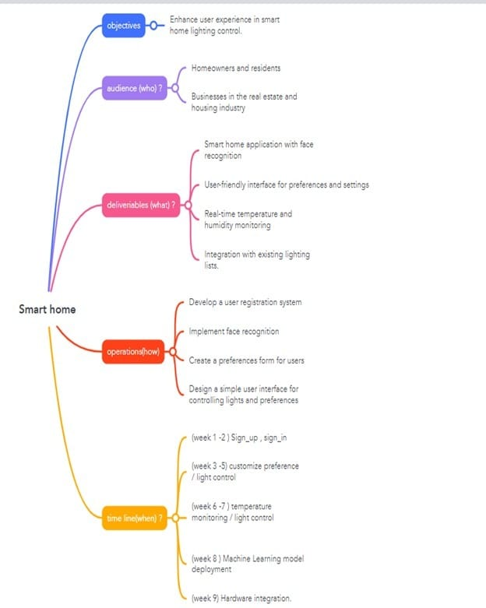

3.2 UML Diagrams

3.2.1 DFD 0

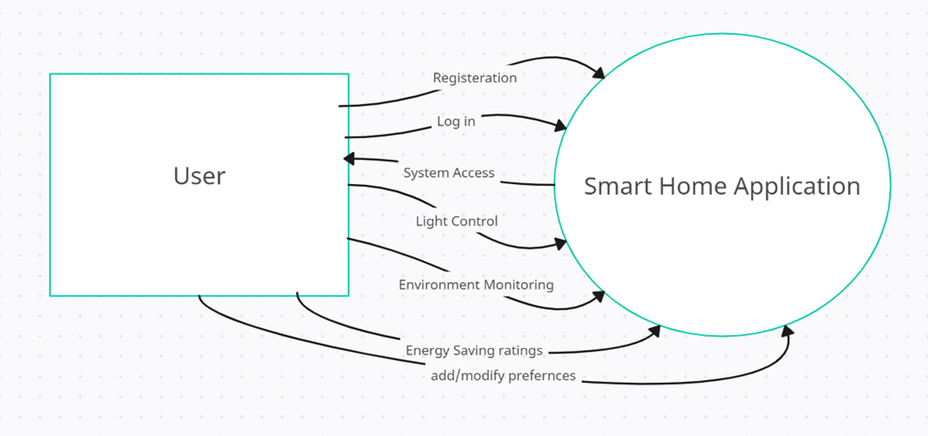

3.2.2 DFD 1
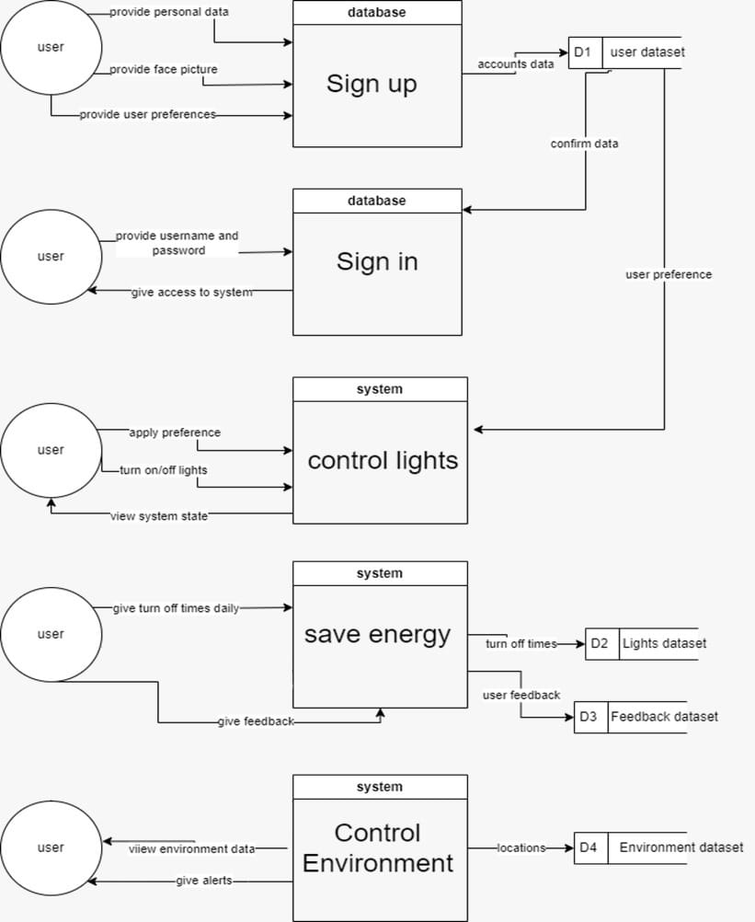

3.2.3 DFD 2
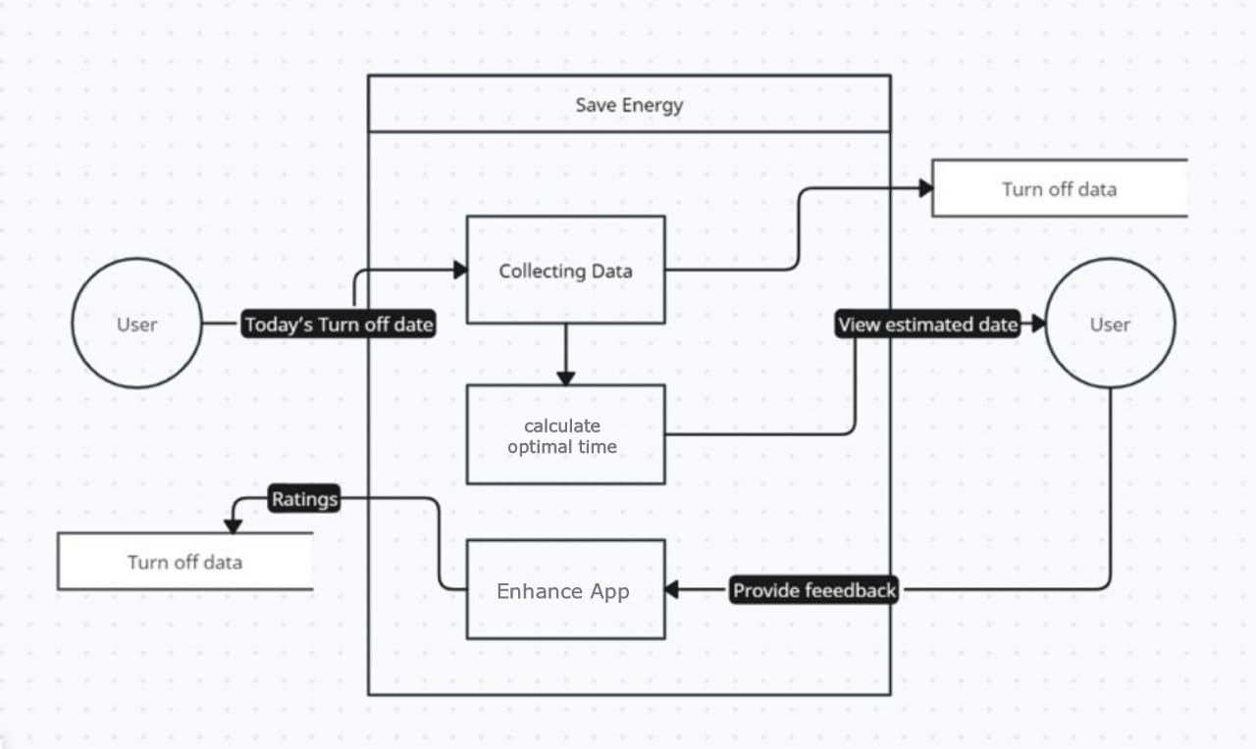

3.3 Use Case Diagram
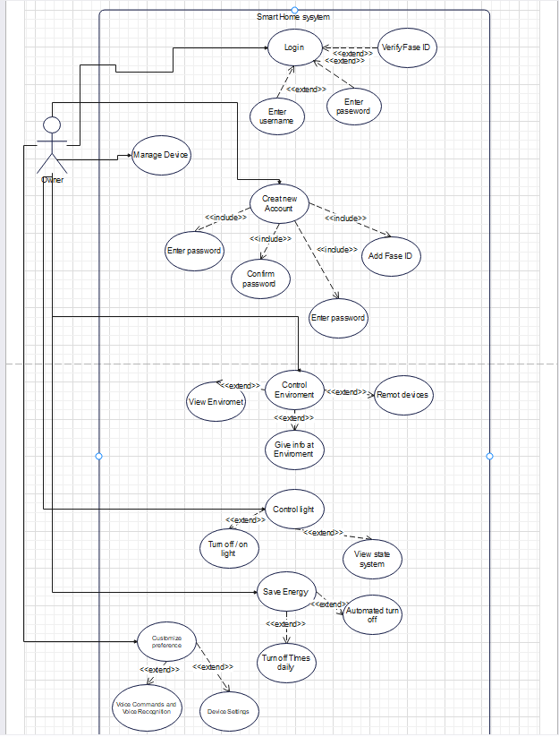

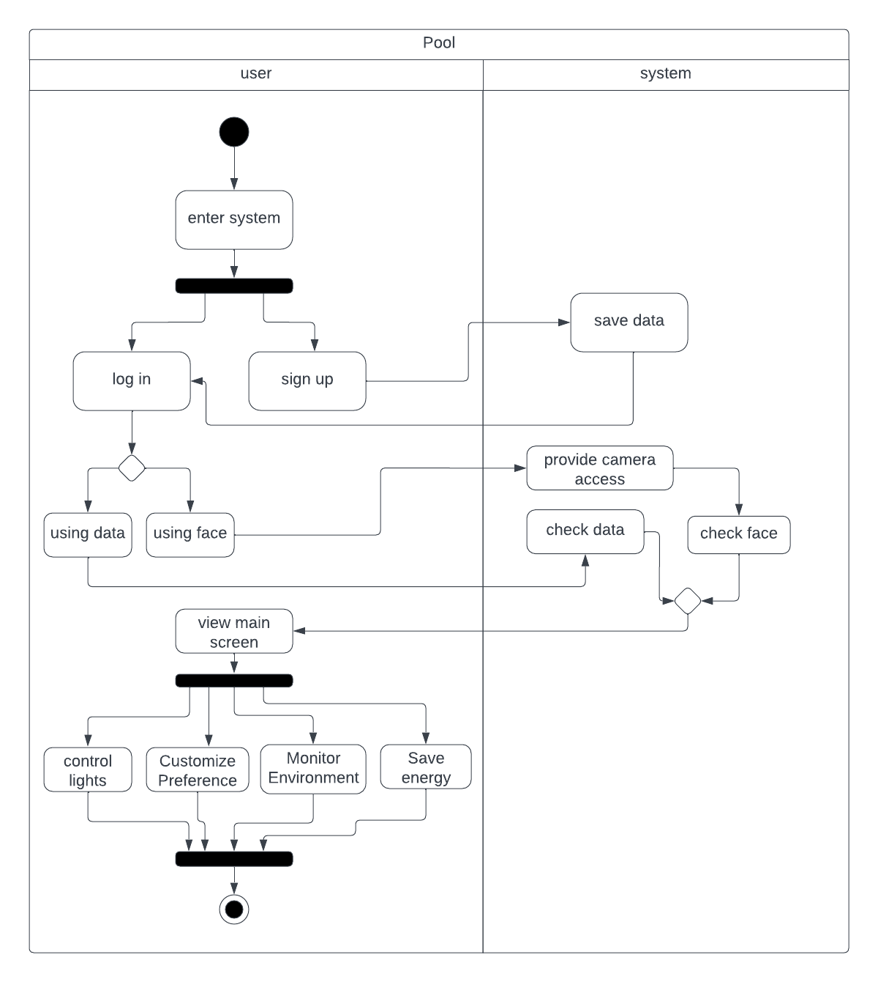
3.4 Activity Diagram

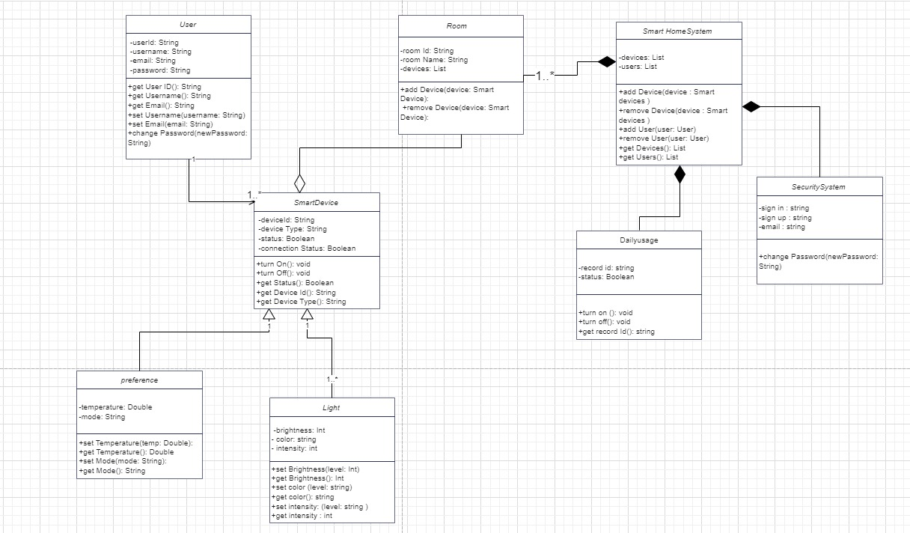
3.5 Class Diagram

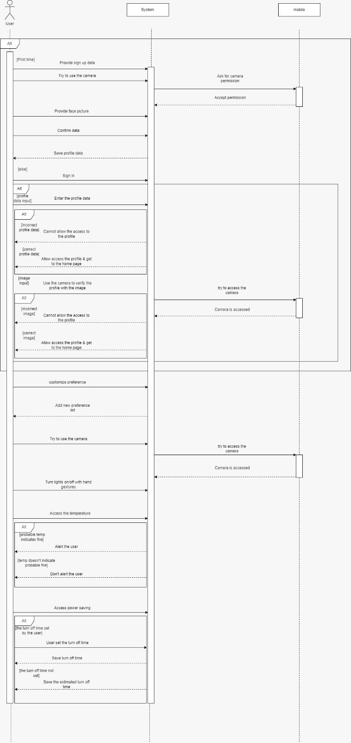
3.6 Sequence Diagram

3.7 State Chart Diagram
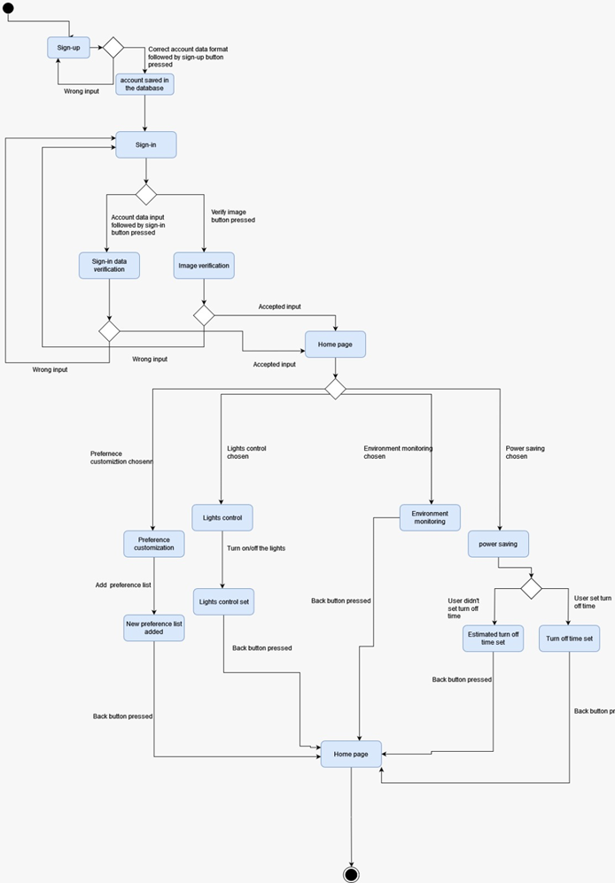

3.8 Technologies and Tools Used

3.8.1 Front End Technology
The front end has several features such as:
Data Management: Backend systems handle the storage and retrieval of data, ensuring seamless access to user information and app content.
User Authentication: Enables secure user logins, protecting sensitive data and ensuring only authorized users access the app.
Scalability: Well-designed backends accommodate growing user bases, ensuring the app performs efficiently as user numbers increase.
Offline Functionality: Backend support allows users to interact with the app offline, syncing data when reconnected.
Push Notifications: Enables timely alerts and updates, enhancing user engagement and communication.
Security Measures: Implement robust security protocols to safeguard user data and maintain privacy.

Native Development:
iOS: Swift (and Objective-C)
Android: Kotlin (and Java)
Native development involves using platform-specific languages and tools to create applications specifically for iOS or Android. This approach allows developers to leverage the full capabilities of each platform.
Cross-Platform Frameworks:
React Native:
Developed by Facebook, it allows developers to use React (a JavaScript library) to build native-like applications for both iOS and Android.
Flutter:
Developed by Google, Flutter uses the Dart programming language to build natively compiled applications for mobile, web, and desktop from a single codebase.
Xamarin:
Developed by Microsoft, Xamarin uses C# and .NET to build cross-platform mobile applications that run on iOS and Android.
Web Technologies (Progressive Web Apps - PWAs):
HTML5, CSS3, JavaScript:
Progressive Web Apps (PWAs) use web technologies to deliver app-like experiences across different devices. They can be accessed through a web browser and offer features like offline capabilities and push notifications.
Hybrid App Frameworks:
Apache Cordova (PhoneGap):
Cordova allows developers to build mobile applications using web technologies (HTML, CSS, JavaScript) and package them as native apps.
Ionic:
Built on top of Angular and Apache Cordova, Ionic is a framework for building hybrid mobile apps using web technologies.
Mobile UI Libraries:
Material-UI for React:
A React UI framework that follows Google's Material Design principles, providing a consistent look and feel across Android devices.
UIKit for Swift (iOS):
A framework for building user interfaces in Swift, providing a set of components and tools for iOS app development.

Flutter:
User Interface (UI) Design:
Flutter provides a rich set of customizable widgets for building visually appealing UIs.
You can design screens for user authentication, lighting preferences, customization, and environment monitoring using Flutter's widget system.
Responsive Layouts:
Flutter allows you to create responsive layouts that adapt to various screen sizes and orientations, ensuring a consistent user experience across different devices.
Authentication Screens:
Design and implement screens for user sign-up, login, and profile settings using Flutter widgets.
Utilize Flutter's navigation system to navigate between authentication screens.
Image Handling:
Flutter provides widgets to handle image uploads and display user profile pictures.
You can use packages like image_picker to enable users to upload face pictures during the sign-up process.
Real-time Updates and Notifications:
Implement real-time features using Flutter's built-in mechanisms or packages like socket_io_client for communication with the Node.js backend.
Utilize Flutter's notification system to alert users about important events or scheduled actions.
Lighting System Preferences and Customization:
Design screens to allow users to set and customize lighting system preferences.
Implement interactive widgets for color selection, intensity adjustment, and other customization options.
Manual Control Buttons:
Create buttons and controls in Flutter for users to manually adjust lights, and ensure they trigger the corresponding actions in the backend.
Machine Learning Model Integration:
If the machine learning model results affect the UI, update the Flutter UI accordingly.
Implement scheduled tasks or background processes in Flutter to trigger the backend's machine learning model at specified times.
API Integration:
Use Flutter's http package or other HTTP client packages to make requests to the Node.js backend APIs for data retrieval and updates.
Handle API responses and update the UI dynamically based on the received data.
Environmental Monitoring:
Design screens to display real-time environmental data retrieved from the Node.js backend.
Utilize Flutter's charting libraries or custom widgets for visualizing temperature and humidity trends.
Integration with Arduino Uno (Hardware):
Communicate with the Node.js backend to control the Arduino Uno.
Implement Flutter widgets to reflect the hardware control options available to users.
Testing and Debugging:
Leverage Flutter's hot reload feature for quick testing and debugging, allowing you to see changes in real time without restarting the app.

3.8.2 Back End Technology:
The backend of a mobile application plays a crucial role in providing various benefits that contribute to the overall functionality, performance, and user experience such as:
Data Management: The backend stores and manages app data securely.
Authentication: Handles user authentication and authorization processes.
Scalability: Enables the app to scale with growing users and data.
Offline Functionality: Supports offline usage and syncs data when online.
Push Notifications: Allows timely updates and alerts to engage users.
Security: Implements measures to protect user data and ensure privacy.
Business Logic: Executes the application's business processes and transactions.

Node.js:
Express.js: A popular web application framework for Node.js, it simplifies the process of building robust and scalable APIs.
Ruby on Rails:
Known for its developer-friendly conventions, Ruby on Rails is a web application framework that facilitates rapid development and clean, maintainable code.
Django (Python):
A high-level Python web framework, Django follows the "don't repeat yourself" (DRY) principle and encourages rapid development.
Java:
Spring Boot: A part of the larger Spring framework, Spring Boot simplifies the process of building production-ready Java applications.
PHP:
Laravel: A PHP web framework that emphasizes elegant syntax and developer-friendly tools, making it suitable for building APIs.
ASP.NET (C#):
ASP.NET Core: A cross-platform, high-performance framework for building modern, cloud-based, and internet-connected applications.
Firebase:
Firebase is a mobile and web application development platform that provides various services such as real-time databases, authentication, cloud functions, and hosting. It is known for its simplicity and ease of integration with mobile apps.

Databases:
SQL (e.g., MySQL, PostgreSQL): Relational databases are commonly used for structured data.
NoSQL (e.g., MongoDB, Firebase Firestore): NoSQL databases are suitable for handling unstructured or semi-structured data.

3.8.3 Machine Learning Models and Algorithms
CNN:
CNNs revolutionized image processing and computer vision. They mimic how humans perceive images by focusing on local patterns and scanning the entire image.
Key components:
Convolutional Layers: Detect features (edges, textures) using convolutional operations.
Pooling Layers: Downsample feature maps to reduce dimensionality.
Fully Connected Layers: Learn high-level representations for classification.
Face Recognition with CNNs:
CNNs excel in face recognition due to their ability to learn hierarchical features.
implementing a face recognition model using CNNs:
Data Preparation:
Collect face images (e.g., cropped faces of individuals).
Split into training and testing sets.
Image Preprocessing:
Resize images to a consistent size (e.g., 64x64 pixels).
Apply data augmentation techniques (shearing, zooming, flipping) to enhance model robustness.
Model Architecture:
Design a CNN architecture (layers, filters, activation functions).
Train the model on the training data.
Prediction:
Evaluate the model on unseen test images.
Map predictions to face names using a lookup table.
Swap numeric tags to obtain face names.
Output Layer:
Use the number of unique faces as output neurons for multi-class classification.
Why CNNs for Face Recognition?
Accuracy: CNNs achieve impressive accuracy in image classification tasks.
Robustness: They handle variations in resolution, illumination, and pose.
Efficiency: Once trained, CNNs can recognize faces swiftly.
Research Advances:
Researchers continue to explore novel architectures, including 3D CNNs, to enhance face recognition even further1.
While simple CNNs work well, more complex models are used in commercial facial recognition systems.

Random Forrest:
What is Random Forest?
Random Forest is a popular machine learning algorithm that falls under the category of supervised learning.
It can be used for both classification and regression tasks.
The core idea behind Random Forest is ensemble learning, which involves combining multiple classifiers to solve complex problems and improve model performance.
Instead of relying on a single decision tree, Random Forest aggregates predictions from multiple decision trees to make a final prediction.
How Does Random Forest Work?
The algorithm operates in two phases:
Building the Random Forest:
Randomly selects K data points from the training set.
Constructs decision trees using these selected data points (subsets).
Repeats this process to create N decision trees.
Making Predictions:
For new data points, each decision tree produces a prediction.
The final output is determined by majority voting—the category with the most votes across all trees.
The greater the number of trees in the forest, the higher the accuracy and the better the prevention of overfitting.
Assumptions for Better Random Forest:
Actual values in the feature variables are crucial for accurate predictions.
Predictions from individual trees should have low correlations.
Why Use Random Forest?
Efficiency:
It requires less training time compared to other algorithms.
It efficiently handles large datasets.

Accuracy:
Random Forest predicts outputs with high accuracy.
It maintains accuracy even when a significant portion of data is missing.

SVM:
Support Vector Machines (SVM) is a supervised machine learning algorithm commonly used for classification and regression tasks. In the context of face recognition, SVM is often applied as a classification algorithm to distinguish between different individuals based on facial features.
SVM in Face Recognition:
Feature Extraction:
Before applying SVM for face recognition, facial features need to be extracted. This could involve techniques such as Principal Component Analysis (PCA), Local Binary Patterns (LBP), or Histogram of Oriented Gradients (HOG) to represent the unique characteristics of faces.
Training:
The SVM model is trained using a dataset of labeled facial features. Each face is associated with a class label, and the SVM learns the optimal hyperplane that separates the different face classes.
Testing and Recognition:
During the testing phase, when a new face is presented, its features are extracted, and the SVM classifies the face based on the learned decision boundary. The output is the predicted class label, representing the identity of the individual.
Kernel Trick for Non-Linear Separation:
In cases where facial features are not easily separable in a linear manner, the SVM can utilize kernel functions (e.g., radial basis function kernel) to map the features into a higher-dimensional space, making non-linear separations possible.

3.9 Prototype

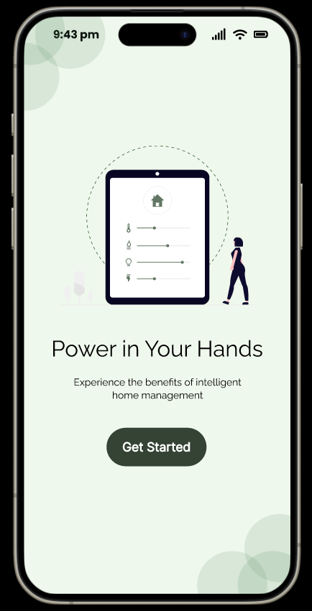

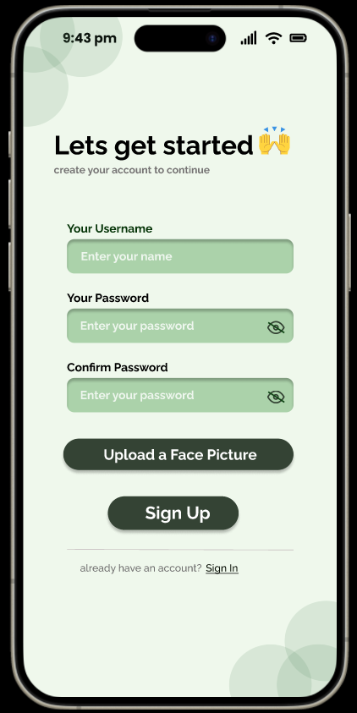

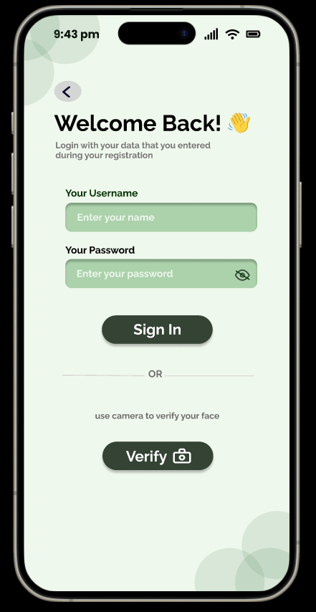
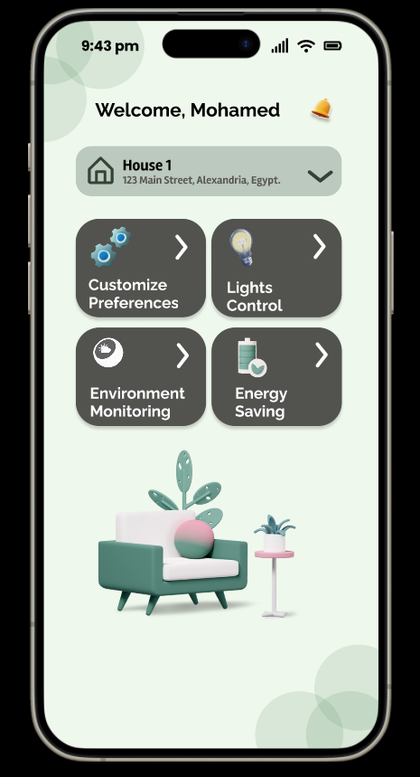
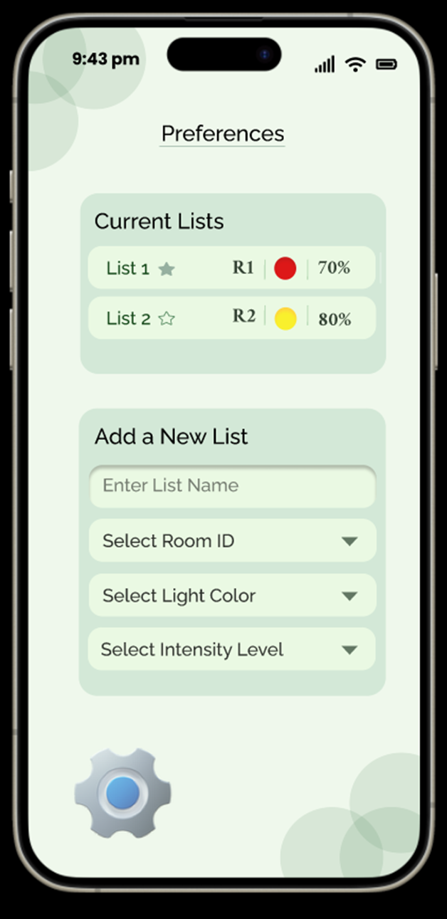

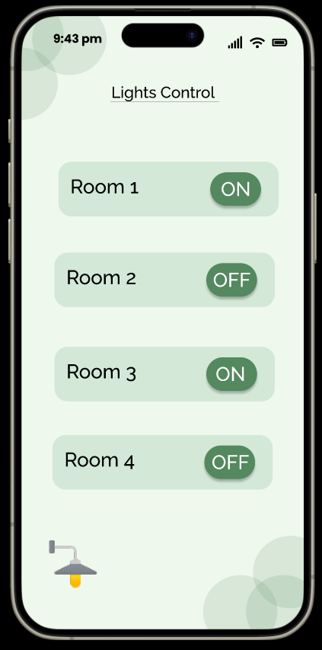

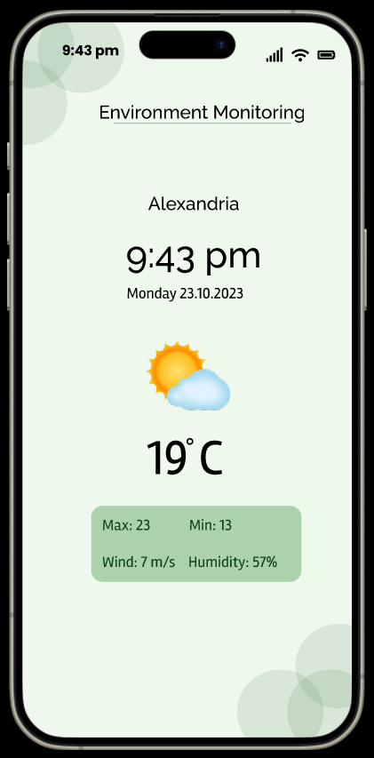

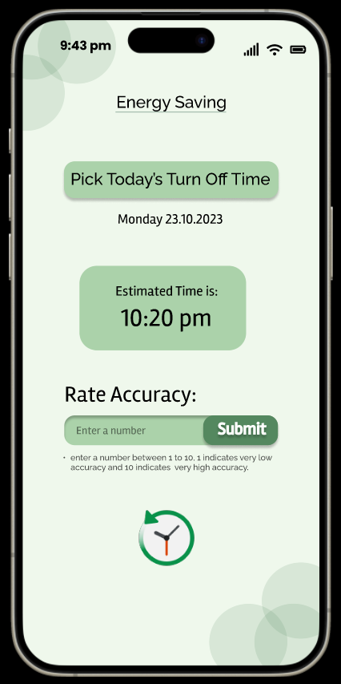

3.10 Implementation Plan
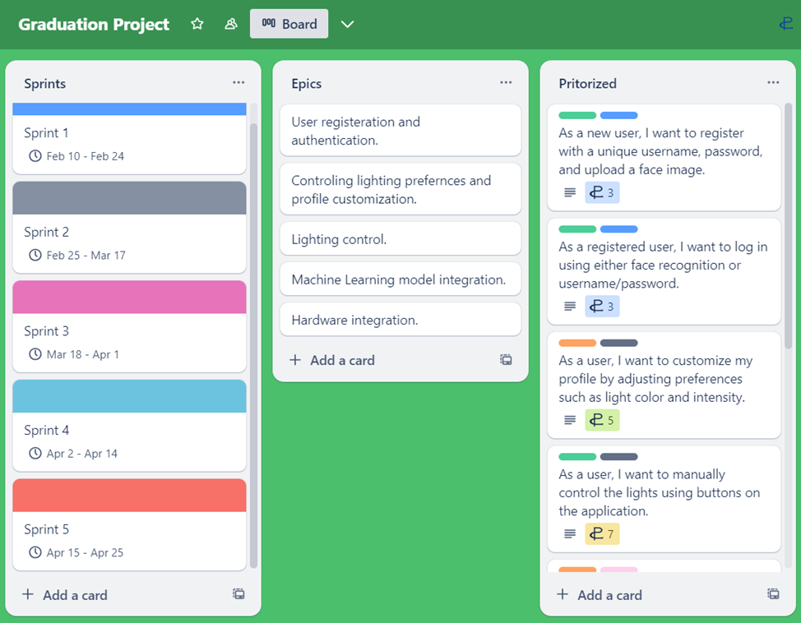

Trello Board Link: https://trello.com/invite/b/6AhyU1XW/ATTIf9454f238804f6f7f6336457cb94fbfaD8E68FA6/graduation-project

Chapter 4 Implementation

4.1 Implementation Environment

4.1.1 Frontend
Flutter, developed by Google, is an open-source UI software development toolkit used for building natively compiled applications for mobile, web, and desktop from a single codebase. Its main strength lies in its ability to create visually attractive and highly performant applications with ease, thanks to its use of the Dart programming language and a comprehensive set of pre-designed widgets.

Flutter's Role in This Project:
Cross-Platform Development: Flutter's ability to develop for both Android and iOS from a single codebase significantly reduces development time and effort, ensuring a consistent user experience across platforms.
Fast Development: The hot-reload feature in Flutter allows for immediate updates to the UI, making the development process quicker and more efficient. This is particularly useful for iterative testing and refining the app’s interface.
Rich UI Components: Flutter's extensive library of pre-designed widgets and flexible design system enables the creation of a highly customized and visually appealing user interface. This is crucial for an app focused on user experience and interaction.
Firebase Integration: Flutter offers seamless integration with Firebase, which is essential for this project’s authentication and data storage needs. Using Firebase, the app can securely store user credentials, preferences, and environmental data.

Key Front-End Features
User Authentication:
Sign Up/Log In: Users can sign up with a username, password, and facial image, and log in using either credentials or face recognition.
UI Design: The authentication pages are designed to be intuitive, ensuring a smooth user onboarding process.
Main Page:
Section Navigation: The main page features four sections—Energy Saving, Environment Monitoring, Light Control, and Preferences—each represented by easily recognizable icons and clear labels.
Preferences:
Customization Options: Users can set light color and intensity for each room, with changes reflected immediately in the app. This page is designed to be interactive and user-friendly.
Energy Saving:
Turn-Off Time Setting: Users can set a daily light turn-off time and view the app’s calculated optimal turn-off time. The layout is straightforward, making it easy for users to understand and interact with the features.
Environment Monitoring:
Real-Time Data Display: This section displays current temperature and humidity readings in an easily readable format, ensuring users can quickly assess their home environment.
Lighting Control:
Control Buttons: Users can turn lights on and off with simple button controls, designed for ease of use and quick response.

4.1.2 Dart
It is a programming language developed by Google, and it offers several features that make it well suited for front-end development and building applications using flutter. It is an open source, purely object-oriented and optionally typed. A class-based language which has excellent support for functional as well as reactive programming. unlike C# or Java.

4.1.3 Backend
Firebase, a platform developed by Google, provides a suite of cloud-based services designed to simplify backend development for mobile and web applications. It offers robust features such as real-time database, authentication, cloud storage, and hosting. Firebase Authentication supports various login methods, including email/password and social media accounts, ensuring secure access to the app. The Firebase Realtime Database enables synchronized data storage and retrieval, making it ideal for applications requiring real-time updates. Firebase's seamless integration with Flutter allows developers to easily incorporate these services into their apps, enhancing functionality and user experience. Additionally, Firebase ensures scalability and reliability, crucial for handling growing user bases and data volumes.

4.2 List of Implementations

4.2.1 Frontend
Tools Used: Flutter is an open-source framework by Google for building beautiful, natively compiled, multiplatform applications from a single codebase. The used language to develop the mobile is Dart. It is used to develop each was page created as the UI (Sign-up-Login-Home page -Products page etc..).

4.2.2 Architecture
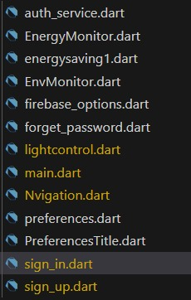

Splash Screen:
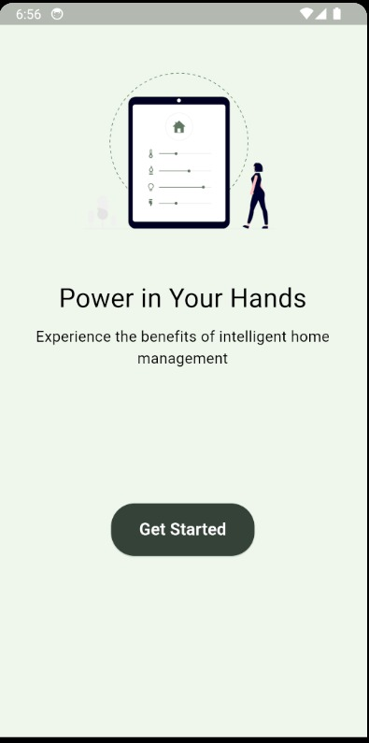

Sign Up:
Users can enter their email and password and provide a face pic for later user in face recognition during sign in.
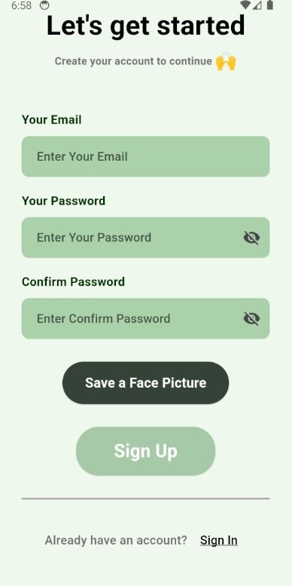

Sign In:
Users can sign in using their email and password or using face id directly.
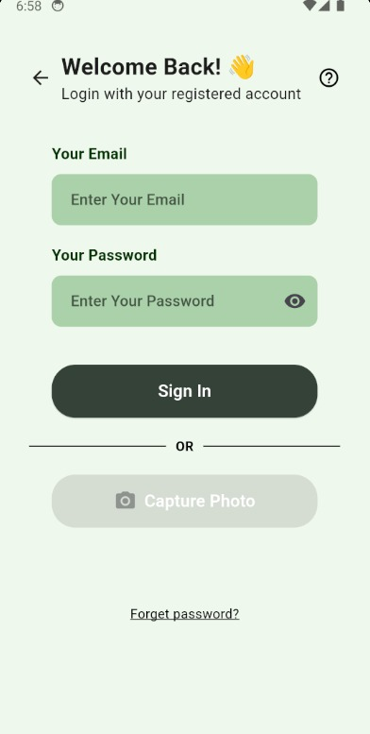

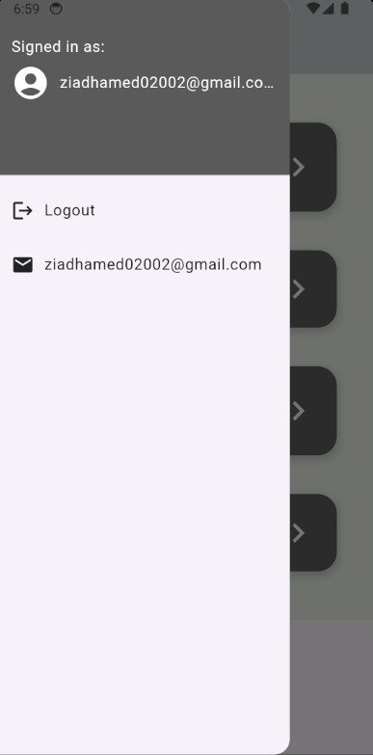

Main Page:
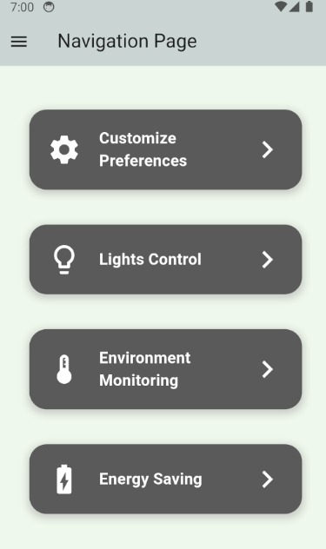
4 sections to navigate between them.

Preferences:
Users can add a new preference list and apply their preferences.
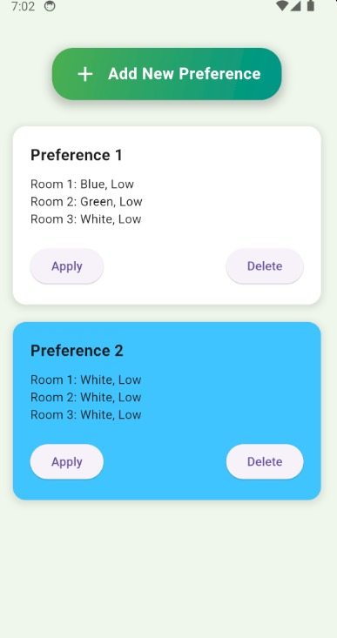

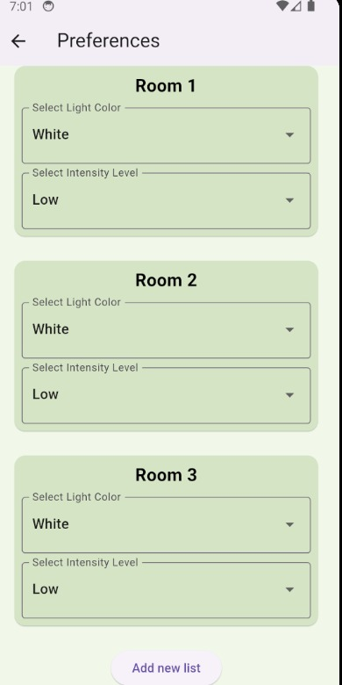

Lighting Control:
Users can turn on/off lights using buttons.

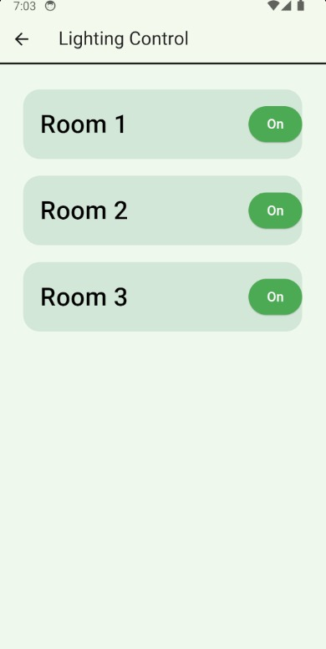

Environment Monitoring:
Users can view the state of temperature and humidity in their location.

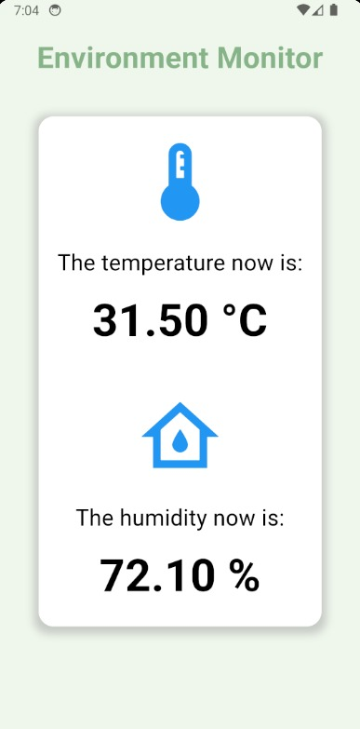

Energy Saving:
Users provide their daily turn off times and the system automatically calculate an optimal time for scheduled turn off.
Users can also provide raring for system accuracy to view their satisfaction level.
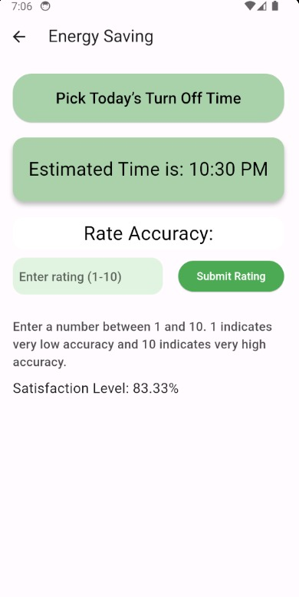

4.2.3 Security and Privacy
1. Firebase
We use Firebase to store the room lighting options for our smart home application.
User Authentication
Secure Login: We use Firebase Authentication to log users in with options like email/password and Google Sign-In.
Secure Data Storage and Transmission
Encrypted Storage: Data in Firebase is encrypted at rest, keeping it safe from unauthorized access.
Encrypted Transmission: All data sent between the app and Firebase is encrypted using TLS/SSL, ensuring privacy and security.
Access Control
Security Rules: We use Firebase Security Rules to control who can read and write data, ensuring only authorized users can access or modify the room lighting configurations.
Regular Updates and Monitoring
Automatic Security Updates: Firebase automatically updates its security features, protecting against new threats.
2. Secure Communication with IoT Devices
We ensure secure communication between the application and IoT devices using MQTT with SSL/TLS encryption. This protects the data transmitted from being intercepted or tampered with.
Encrypted Communication: All messages between the app and IoT devices are encrypted using SSL/TLS.
3. Firmware and Software Updates
We ensure both the mobile application and IoT devices receive secure, signed firmware and software updates. Regular updates are applied to patch vulnerabilities and enhance security.
Secure Updates: All updates are signed to prevent tampering.

Chapter 5 Testing
1) Test Plan Identifier
TP-SHM-001 (Test Plan for Smart Home Management System)
2.Reference Material
Project Policies:
•Test Environment Policy: The test environment will be managed by the team responsible for the Configuration Management, and access will be restricted to authorized personnel. Environment configurations will be documented and version-controlled to ensure consistency across testing phases.
Standards:
•IEEE829 – Software & System Test Documentation
3.Introduction
Objectives
1: improve homeowners' quality of life by offering a tailored and energy-efficient lighting control experience.
2: strive to encourage sustainable living practices by utilizing intelligent lighting control to lower energy consumption.
3: establish our application as a premier solution in the smart home market, surpassing existing products.
4: Our revenue streams include product sales and potential partnerships with technology companies.

4.Test Items
User Authentication (Sign Up and Login)
Energy Saving Module
Environment Monitoring Module
Light Control Module
Preferences Module
Firebase Integration
5. Software Risk Issues
Potential security vulnerabilities in user authentication, especially with face recognition.
Data synchronization issues with Firebase, leading to inconsistent data.
Performance bottlenecks due to real-time data updates.
User interface responsiveness across different devices and screen sizes.
Integration issues between different modules (e.g., preferences affecting light control).
6.Features To Be Tested
•Valid User Registration: Verify successful user registration with valid Credentials.
•Valid User Login: Validate user login with correct credentials.
•Password: Confirm secure password recovery process.
•Connectivity: Test the application's connectivity options, such as Wi-Fi, Bluetooth, or Zigbee. Ensure that devices can be reliably connected, disconnected, and reconnected without issues.
•Performance and Scalability: Test the application's performance under different load conditions, including a large number of connected devices or simultaneous user interactions. Verify that the application can handle the expected scale without significant performance degradation.
7.Features Not To Be Tested
1-Device-Specific Functionality: If a device's functionality lies outside the scope of the smart home app, it may not need extensive testing within the app.
2- External Connectivity Issues: Testing external factors like Wi-Fi outages or server downtimes might be excluded as they are beyond the application's control.
8.Approach
1. Integration Testing:
Purpose: Integration testing in smart home applications is performed to ensure that different components, devices, and systems can seamlessly integrate and work together as intended. The goal is to identify any interoperability issues, communication failures, or compatibility problems between the smart home application and the connected devices.
Types
- Device Integration Testing: This type of testing focuses on verifying the integration between the smart home application and individual devices. It ensures that devices can be discovered, connected, and controlled through the application.
- System Integration Testing: This testing validates the integration between the smart home application and the larger smart home ecosystem. It involves testing the communication and interoperability between multiple devices, systems, and protocols.
1-Device-Specific Functionality: If a device's functionality lies outside the scope of the smart home app, it may not need extensive testing within the app.
2-External Connectivity Issues: Testing external factors like Wi-Fi outages or server downtimes might be excluded as they are beyond the application's control.
9.Pass / Fail Criteria
1 - Suspension Criteria
•Not having access to the system.
•Not having the required resources necessary to test with.
•Not having clear requirements to properly test the system.
•Having critical defects in the core functionalities that require immediate resolution.
•Having environmental issues that prevent accurate and reliable testing.
2 - Resumption Criteria
•Gaining access to the system.
•Gaining the required resources to test with.
•Having clear requirements to test with.
•Resolution of the defects found in the core functionalities.
•Having a testing environment ready for testing.
10.Suspension Criteria and Resumption Requirements
Suspension Criteria: Testing will be suspended if critical defects are found that block further testing or if the test environment becomes unavailable.
Resumption Requirements: Testing will resume once the critical defects are resolved and validated, and the test environment is restored to a functional state.
11.Test Deliverables
Test Plan Document (this document)
Test Cases and Test Scripts (detailed test cases for all features)
Test Execution Reports (logs of executed test cases and results)
Defect Reports (detailed reports on identified defects, including severity and steps to reproduce)
Final Test Summary Report (overview of testing outcomes, including pass/fail rates and remaining issues)
12.RemainigTesting Tasks
The testing tasks can be categorized based on the testing activities being performed. Here are the common testing tasks and their descriptions:
- Test Planning:
- Define the test objectives, scope, and strategy.
- Identify the testing resources, including personnel, tools, and environments.
- Develop the test plan, specifying the approach and schedule.
- Test Design:
- Create test cases based on requirements and design specifications.
- Develop test data to support test cases.

13.Environmental Requirements200
1.Hardware
- Mobile Phone
- Tablets
- Wi-Fi Connection
- Mobile Data Connection
- Tv
- Smart devices
2.Internet connectivity for real-time data synchronization with Firebase.
3.Firebase project setup with necessary configurations for authentication, database, and storage.
14. Staffing and Training Needs
Test Manager: Responsible for overall test plan management, schedule tracking, and coordination.
Test Engineers: Experienced in mobile application testing and familiar with Flutter and Firebase, responsible for test case design, execution, and defect logging.
Developers: Available to fix reported defects and assist with technical issues during testing.
Training: Conduct training sessions on specific tools and technologies used (e.g., Flutter, Firebase), as well as security best practices for user authentication.
15.Responsibilities
Test Manager: [Name], managing the test plan, ensuring resources are available, and tracking the testing progress.
Test Engineers: [Names], designing and executing test cases, logging defects, and conducting regression testing.
Developers: [Names], fixing defects and providing technical support during the testing process.
Project Manager: [Name], ensuring overall project timelines are met and coordinating between development and testing teams.
16.Schedule
Test Plan Review: [2024-05-20]
Test Case Preparation: [2024-05-21] to [2024-05-23]
Test Environment Setup: [2024-05-25]
Test Execution: [2024-05-26] to [2024-05-31]
Defect Resolution: [2024-06-1] to [2024-06-06]
User Acceptance Testing (UAT): [2024-06-07] to [2024-06-12]
Final Report: [2024-06-15]
17. Planning Risks and Contingencies
Risk: Delays in test environment setup.
Contingency: Utilize virtual environments or cloud-based testing platforms if physical devices are unavailable.
Risk: Critical defects blocking progress.
Contingency: Prioritize defect fixing and retesting, and maintain a buffer period in the schedule for unforeseen issues.
Risk: Limited availability of testers or developers.
Contingency: Cross-train team members to handle multiple roles and hire temporary staff if necessary.
18.Approvals
Test Plan Approval by Test Manager: [Mohamed Tarek, 17/6/2024]
Test Plan Approval by Project Manager: [Abdelrahman Kamal, 17/6/2024]
Test Plan Approval by Development Lead: [Ziad Hamed, 17/6/2024]
19.Test Cases
ID# | Step number | Step Details | Expected Results | Actual Results | Test Status
TC-001 | 1. | Enter Valid Username | Successful Login | Successful Login | Passed
TC-001 | 2. | Enter Valid Password | Successful Login | Successful Login | Passed
TC-001 | 3. | Click ‘Login’ Button | Successful Login | Successful Login | Passed
TC-002 | 1. | Enter Valid Username | Failed Login | Failed Login | Passed
TC-002 | 2. | Enter Invalid Password | Failed Login | Failed Login | Passed
TC-002 | 3. | Click ‘Login’ Button | Failed Login | Failed Login | Passed
TC-003 | 1. | Enter Invalid Username | Failed Login | Failed Login | Passed
TC-003 | 2. | Enter Valid Password | Failed Login | Failed Login | Passed
TC-003 | 3. | Click ‘Login’ Button | Failed Login | Failed Login | Passed
TC-004 | 1. | Enter Invalid Username | Failed Login | Failed Login | Passed
TC-004 | 2. | Enter Invalid Password | Failed Login | Failed Login | Passed
TC-004 | 3. | Click ‘Login’ Button | Failed Login | Failed Login | Passed
TC-005 | 1. | Turn On Wi-Fi Connection | Successfully Connected | Successfully Connected | Passed
TC-005 | 2. | Open Application | Successfully Connected | Successfully Connected | Passed
TC-005 | 3. | Check Connection | Successfully Connected | Successfully Connected | Passed
TC-006 | 1. | Turn Off Wi-Fi Connection | Failed To Connect | Failed To Connect | Passed
TC-006 | 2. | Open Application | Failed To Connect | Failed To Connect | Passed
TC-006 | 3. | Check Connection | Failed To Connect | Failed To Connect | Passed
TC-007 | 1. | Turn On 4G Connection | Successfully Connected | Successfully Connected | Passed
TC-007 | 2. | Open Application | Successfully Connected | Successfully Connected | Passed
TC-007 | 3. | Check Connection | Successfully Connected | Successfully Connected | Passed
TC-008 | 1. | Turn Off 4G Connection | Failed To Connect | Failed To Connect | Faild
TC-008 | 2. | Open Application | Failed To Connect | Failed To Connect | Faild
TC-008 | 3. | Check Connection | Failed To Connect | Failed To Connect | Faild
TC-009 | 1 | Open Application | Failed To Connect | Failed To Connect | Faild
TC-009 | 2 | Check Connection | Failed To Connect | Failed To Connect | Faild
TC-009 | 3 | Connection with devices from 100m | Failed To Connect | Failed To Connect | Faild
TC-009 | 1 | Open Application | Successfully Connected | Successfully Connected | Passed
TC-009 | 2 | Check Connection | Successfully Connected | Successfully Connected | Passed
TC-009 | 3 | Connection with devices from 50m | Successfully Connected | Successfully Connected | Passed
TC-010 | 1 | Open Application | Successfully Connected | Successfully Connected | Passed
TC-010 | 2 | Check Connection | Successfully Connected | Successfully Connected | Passed
TC-010 | 3 | Connection with 6 device | Successfully Connected | Successfully Connected | Passed
TC-010 | 1 | Open Application | Failed To Add extra device | Failed To Add extra device | Faild
TC-010 | 2 | Check Connection | Failed To Add extra device | Failed To Add extra device | Faild
TC-010 | 3 | Connection with more than 6 device | Failed To Add extra device | Failed To Add extra device | Faild
TC-011 | 1 | Open Application | Failed To Connect device | Failed To Connect  Device | Faild
TC-011 | 2 | Check Connection | Failed To Connect device | Failed To Connect  Device | Faild
TC-011 | 3 | Connect to unsupportive device | Failed To Connect device | Failed To Connect  Device | Faild
TC-012 | 1 | Open Application | Successfully Connected | Successfully Connected | Passed
TC-012 | 2 | Check Connection | Successfully Connected | Successfully Connected | Passed
TC-012 | 3 | Connect to Supported devices | Successfully Connected | Successfully Connected | Passed
TC-013 | 1 | Open Application | Successfully Connected | Successfully Connected | Passed
TC-013 | 2 | Connection device | Successfully Connected | Successfully Connected | Passed
TC-013 | 3 | Send Notification | Successfully Connected | Successfully Connected | Passed
TC-014 | 1 | Open Application | Successfully Connected | Successfully Connected | Passed
TC-014 | 2 | Send Notification | Successfully Connected | Successfully Connected | Passed
TC-014 | 3 | View notification | Successfully Connected | Successfully Connected | Passed
TC-015 | 1 | Open Application | Successfully  Removed | Successfully  Removed | Passed
TC-015 | 2 | Check devices | Successfully  Removed | Successfully  Removed | Passed
TC-015 | 3 | Remove device | Successfully  Removed | Successfully  Removed | Passed
TC-016 | 1 | Open Application | Successfully Light Turns On | Successfully Connected | Passed
TC-016 | 2 | Navigate to 'Lights' Section | Successfully Light Turns On | Successfully Connected | Passed
TC-016 | 3 | Turn On Room Light | Successfully Light Turns On | Successfully Connected | Passed
TC-017 | 1 | Open Application | Successfully  Light Turns Off | Successfully  Light Turns Off | Passed
TC-017 | 2 | Navigate to 'Lights' Section | Successfully  Light Turns Off | Successfully  Light Turns Off | Passed
TC-017 | 3 | Turn Off Room Light | Successfully  Light Turns Off | Successfully  Light Turns Off | Passed
TC-018 | 1 | Open Application | Light Turns On | Light Remains Off | Failed
TC-018 | 2 | Navigate to 'Lights' Section | Light Turns On | Light Remains Off | Failed
TC-018 | 3 | Turn On Room Light | Light Turns On | Light Remains Off | Failed
TC-019 | 1 | Open Application | Successfully  Removed | Successfully  Removed | Passed
TC-019 | 2 | Navigate to 'Lights' Section | Successfully  Removed | Successfully  Removed | Passed
TC-019 | 3 | Turn Off Room Light | Successfully  Removed | Successfully  Removed | Passed
TC-020 | 1 | Open Application | Light Turns Off | Light Remains On | Failed
TC-020 | 2 | Send Notification | Light Turns Off | Light Remains On | Failed
TC-020 | 3 | View notification | Light Turns Off | Light Remains On | Failed
TC-021 | 1 | Open Application | Temperature Set to 22°C | Temperature Set to 22°C | Passed
TC-021 | 2 | Navigate to 'Thermostat' Section | Temperature Set to 22°C | Temperature Set to 22°C | Passed
TC-021 | 3 | Temperature to 22°C | Temperature Set to 22°C | Temperature Set to 22°C | Passed
TC-021 | 1 | Open Application | Temperature Set to 22°C | temperature Remains Unchanged | Failed
TC-021 | 2 | Navigate to 'Thermostat' Section | Temperature Set to 22°C | temperature Remains Unchanged | Failed
TC-021 | 3 | Temperature to 22°C | Temperature Set to 22°C | temperature Remains Unchanged | Failed

Key Stakeholders:
- Homeowners: personalized control, and remote management of their home
- Administrator: Efficient management and monitoring of connected devices, integration with other systems.
- Developers: Create or remove system features or modify
- Testers: Quality assurance and bug free operation.
- Designer: Overseeing the overall project, ensuring it aligns with the objectives, scope, and timelines.

Project Team:
- Developers: Create or remove system features or modify
- Testers: Quality assurance and bug free operation.
- Designer: Overseeing the overall project, ensuring it aligns with the objectives, scope, and timelines.

Testing Strategy
Integration testing can be used for a smart home application project to ensure that the various components of the application work together seamlessly. It focuses on testing the interactions between different modules, subsystems, or devices within the smart home system to verify that they integrate correctly and function as expected.
Usability testing in a smart home application project can be used to evaluate the user experience and identify areas for improvement. It focuses on understanding how users interact with the application, their ease of use, and satisfaction with the overall user interface and features.
Performance testing in a smart home application project can be used to evaluate the application's performance characteristics, such as responsiveness, scalability, and resource usage. It helps ensure that the application can handle the expected workload and deliver a satisfactory user

Chapter 6 Conclusion and Future Work

6.1 Conclusion
The Smart Home Management System project epitomizes the convergence of cutting-edge technology and practical living solutions, aimed at transforming traditional homes into smart, efficient environments. It integrates a suite of sophisticated functionalities, including secure user authentication, energy-efficient lighting control, real-time environmental monitoring, and seamless Firebase integration, all designed to enhance user comfort, streamline daily routines, and promote sustainability.
At its core, the system ensures secure user authentication through a dual-method approach—username/password and facial recognition—enabled by Firebase authentication services. This not only prioritizes user security but also facilitates seamless access across devices, ensuring a frictionless user experience from initial setup to daily use.
Energy efficiency is a cornerstone of the system, offering users the ability to set personalized daily turn-off times for lights and receive optimized suggestions based on usage patterns and environmental conditions. This feature not only reduces energy consumption but also lowers utility costs and supports environmentally conscious living.
Real-time environmental monitoring provides users with instant insights into indoor temperature and humidity levels, empowering proactive adjustments to maintain optimal comfort. This capability is particularly valuable for ensuring a healthy and pleasant living environment, adapting dynamically to changing conditions throughout the day.
Integrated lighting control allows for granular customization of light settings across different rooms, from color and intensity preferences to scheduling. The intuitive interface ensures effortless adjustments, enhancing ambiance while maximizing energy efficiency based on individual preferences and daily routines.
Firebase integration serves as the backbone of the system, enabling seamless data synchronization, secure storage, and reliable performance across all components. This integration not only supports real-time updates of user preferences and environmental data but also ensures scalability and responsiveness as the system expands to accommodate future enhancements and user needs.
In conclusion, the Smart Home Management System represents a significant advancement in home automation, leveraging advanced technologies to redefine residential living. By combining secure authentication, energy-efficient controls, environmental monitoring, and robust data management through Firebase, the system offers a holistic solution that enhances convenience, improves energy efficiency, and supports sustainable living practices.
Looking forward, ongoing innovation and community engagement will drive continued enhancements and adoption of smart home technologies. Ethical considerations, including user privacy and data security, remain paramount, guiding the system's development to uphold user trust and compliance with regulatory standards.
Collaboration with stakeholders, including developers, testers, and end-users, has been instrumental in shaping the system's features, usability, and performance. Their feedback and insights continue to inform iterative improvements and future developments, ensuring that the Smart Home Management System remains at the forefront of smart home innovation.
In summary, the Smart Home Management System embodies the future of residential living, offering a seamless blend of convenience, efficiency, and sustainability. As technology evolves and user expectations grow, the system is poised to lead the way in optimizing home environments, enriching daily lives, and contributing to a more connected and environmentally responsible future.

6.2 Future Work
The evolution of the Smart Home Management System will likely focus on expanding its capabilities to encompass a broader range of smart devices and IoT technologies. This includes integrating with smart appliances such as thermostats, security systems, and kitchen appliances, creating a truly interconnected home ecosystem.
Future iterations could prioritize enhanced predictive analytics capabilities, leveraging machine learning algorithms to anticipate user preferences and automate home management tasks more intelligently. This could include predictive scheduling of lighting and HVAC systems based on historical usage patterns and real-time environmental data.
There is potential to integrate voice recognition technology, allowing users to control various aspects of their smart home environment through natural language commands. This would enhance accessibility and convenience, providing a hands-free interface for managing daily routines.
Exploring augmented reality (AR) and virtual reality (VR) interfaces could revolutionize user interaction with the smart home environment, offering immersive experiences for configuring settings, monitoring energy usage, and visualizing environmental data in real-time.
Enhancing cybersecurity measures will remain critical, with continuous improvements in data encryption, secure communication protocols, and proactive threat detection to safeguard user privacy and protect against emerging cyber threats.
Integration with renewable energy systems, such as solar panels and energy storage solutions, could enable the system to optimize energy usage further and facilitate a more sustainable energy footprint for homeowners.
Exploring partnerships with utility providers could enhance the system's ability to provide real-time energy consumption insights and facilitate energy-saving incentives or rebates for users based on their smart home's efficiency.
Incorporating health and wellness monitoring features could expand the system's functionality to include monitoring air quality, allergen levels, and other environmental factors that impact occupant health and comfort.
Future developments might include seamless integration with smart city initiatives, enabling data sharing and collaboration with municipal services to optimize resource usage and improve urban sustainability.
Continued research and development in sensor technology could lead to more advanced environmental sensors capable of detecting a wider range of parameters, enhancing the system's ability to provide precise and actionable insights.
Integrating biometric authentication methods, such as fingerprint or voice recognition, could offer additional layers of security and convenience for accessing the smart home system and sensitive data.
The system could explore adaptive learning algorithms that continuously refine user preferences and automation settings based on ongoing feedback and behavioral patterns, ensuring personalized and efficient home management.
Exploring sustainability certifications and standards compliance could enhance the system's appeal to environmentally conscious consumers and ensure adherence to best practices in energy efficiency and resource conservation.
Researching advanced data visualization techniques could enhance the system's ability to present complex data insights in intuitive and actionable formats, empowering users to make informed decisions about their home environment.
Investigating distributed computing and edge computing solutions could enhance the system's scalability and responsiveness, enabling faster data processing and real-time decision-making at the device level.
Researching renewable energy forecasting algorithms could optimize the system's integration with solar and wind power sources, maximizing energy generation and consumption efficiency based on weather patterns and forecasts.

Chapter 7 Appendix A

7.1 Sample User Flow

1. User Registration and Setup
Step 1.1: Open the Smart Home app.
Step 1.2: Select "get started" on the welcome screen.
Step 1.3: Enter required information:
-Email address
-Password
Step 1.4: Take a picture of your face using the camera for facial recognition.
Step 1.5: Submit the registration form.
Step 1.6: Log in using the newly created email and password or use facial recognition.

2. Main Dashboard Navigation
Step 2.1: Upon successful login, the main dashboard appears with four sections:
- Energy Saving
- Environment Monitoring
- Light Control
- Preferences

3. Preferences Setup
Step 3.1: Tap on "Preferences."
Step 3.2: View the existing list of light settings for each room.
Step 3.3: Tap "Add New Preference."
Step 3.4: Select a room and adjust the light color and intensity.
Step 3.5: Tap "Apply" to save the settings.
Step 3.6: Return to the main dashboard.

4. Energy Saving Configuration
Step 4.1: Tap on "Energy Saving."
Step 4.2: Choose a daily turn-off time for the lights.
Step 4.3: View the suggested optimal turn-off time calculated by the system.
Step 4.4: Confirm the selected turn-off time.
Step 4.5: Rate the accuracy of the system's suggestion using the "User Satisfaction" label (1 to 10).
Step 4.6: Return to the main dashboard.

5. Environment Monitoring
Step 5.1: Tap on "Environment Monitoring."
Step 5.2: View current temperature and humidity readings from the DHT22 sensor.
Step 5.3: Return to the main dashboard.

6. Lighting Control
Step 6.1: Tap on "Light Control."
Step 6.2: View buttons to turn lights on or off for each room.
Step 6.3: Toggle the lights on/off as needed.
Step 6.4: Return to the main dashboard.

7.2 Code

7.2.1 Dart
Check Login Status and Update State
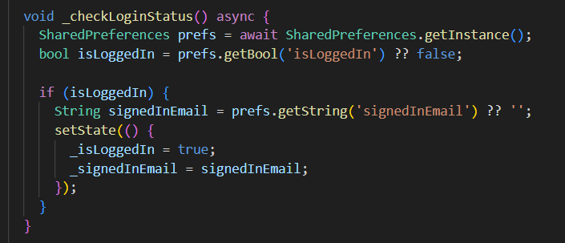

Save image to firebase
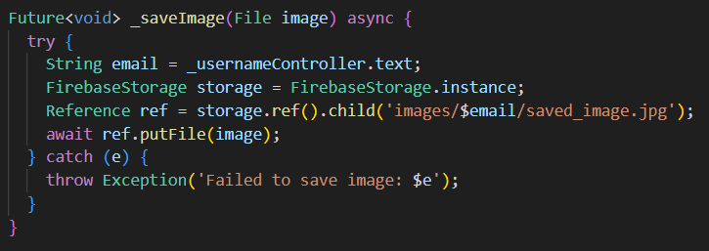

Sign Up User and Initialize Database
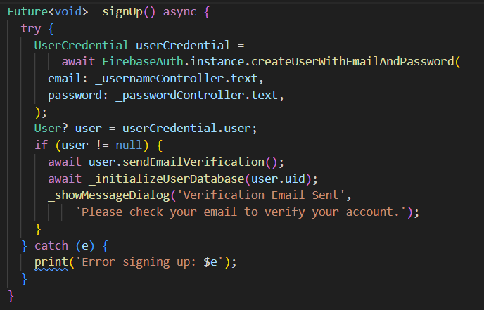

Initialize User Database
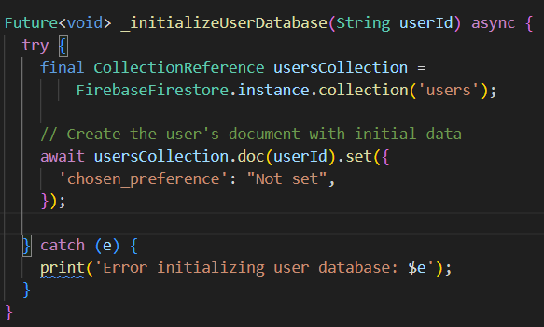

Validate Email Format

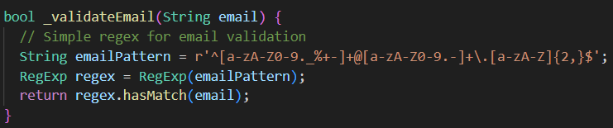

Show Error Dialog
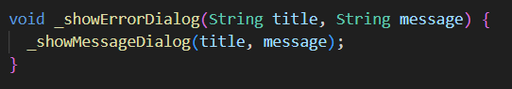

Show Message Dialog

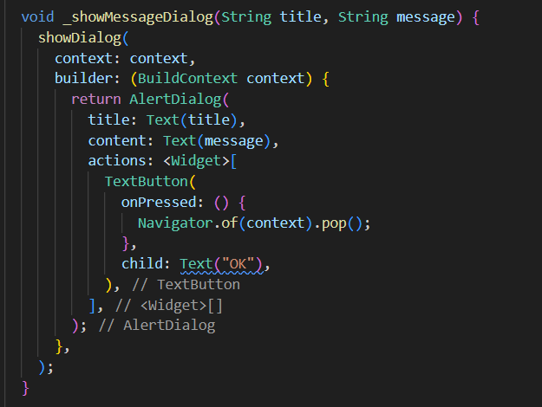

Calculate Password Strength

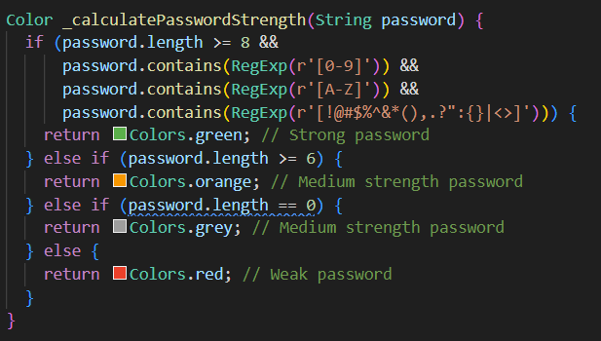

Show Invalid Inputs Dialog
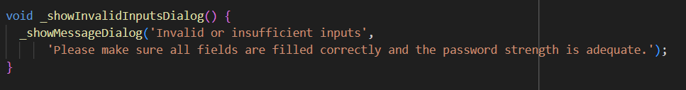

Capture Image and Show Dialog
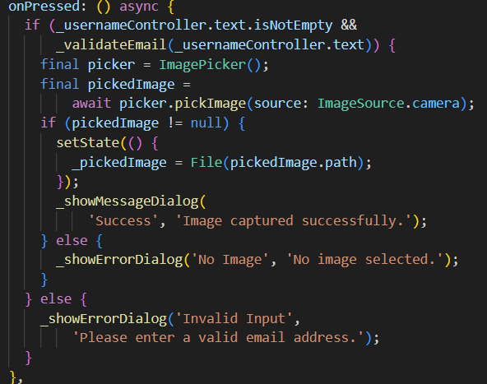

Check if Email is Filled

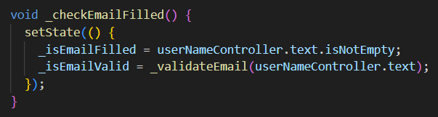

Pick Image
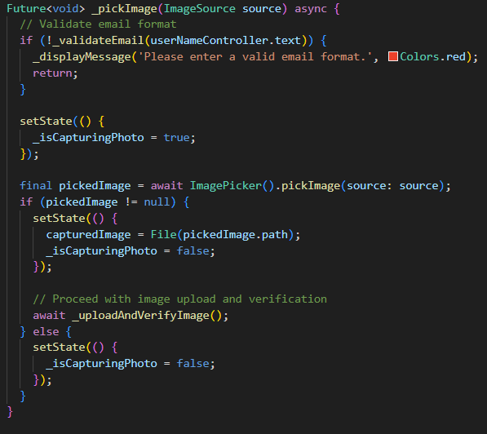

Upload and Verify Image
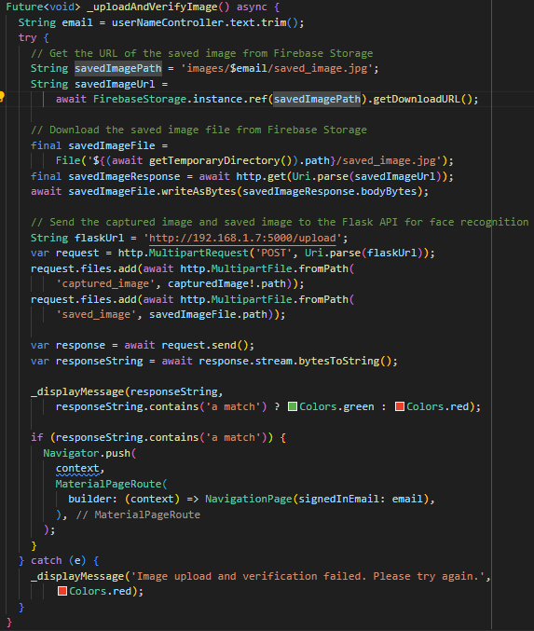

Display Message

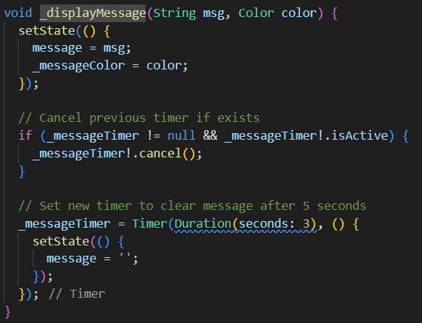

Room Settings State Management

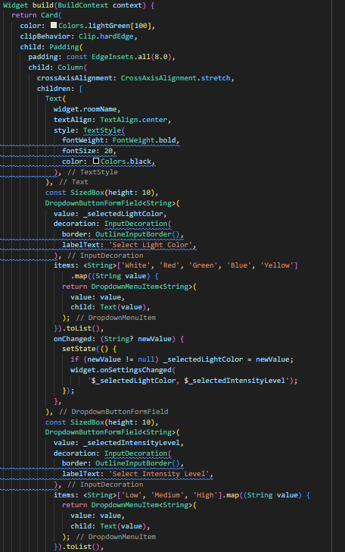

Room Settings State Management

Room Settings State Management

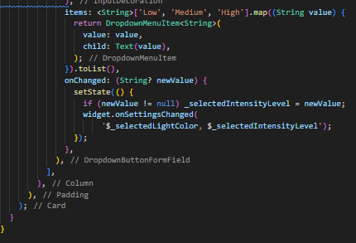

Save preferences

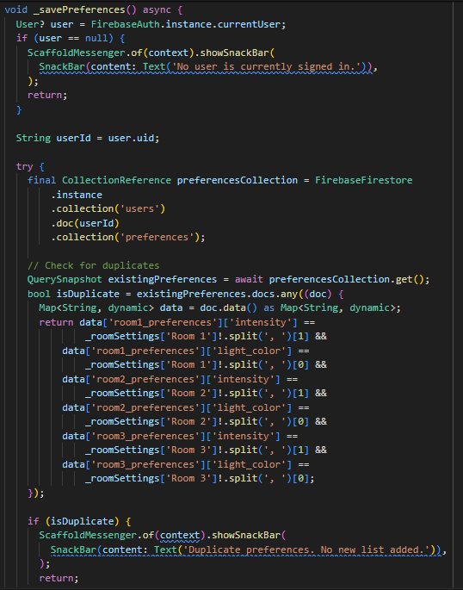

Save preferences

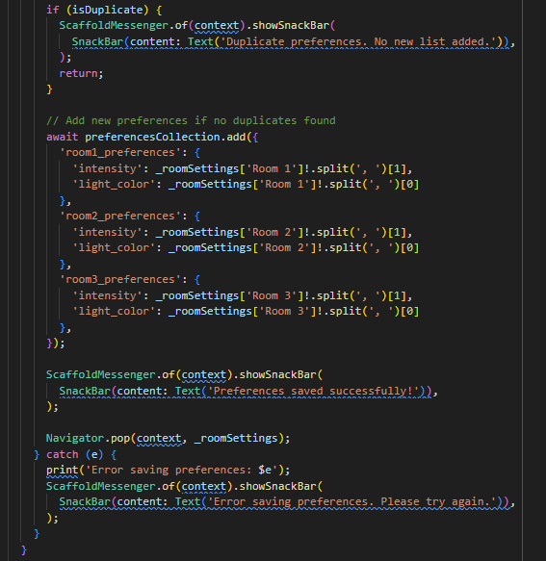

Preferences page

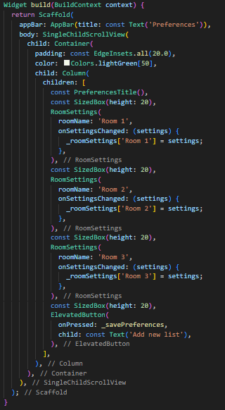

Load preferences

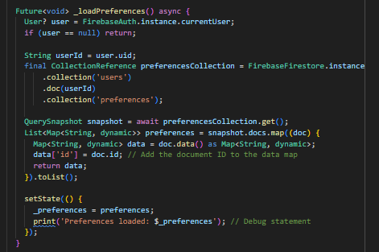

Load chosen preference

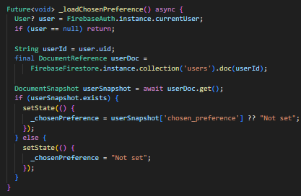

Add preferences

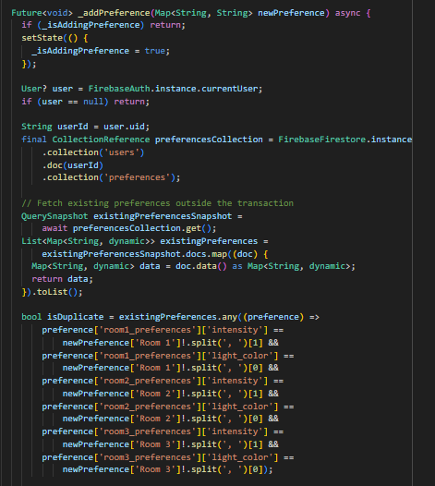

Add preferences

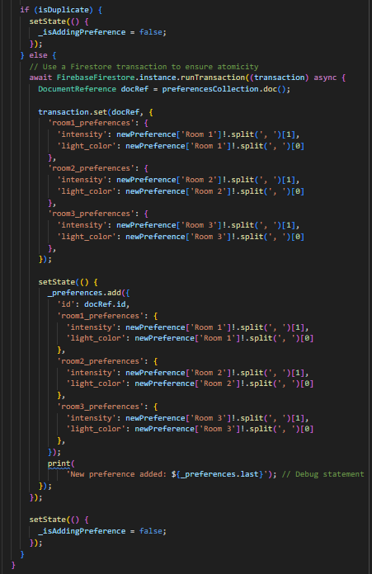

Apply preference

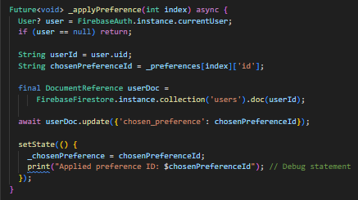

Check preference existence

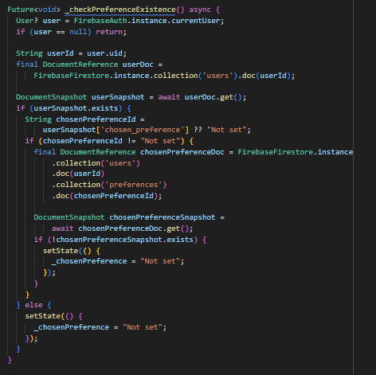

Delete preference

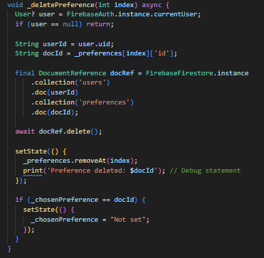

Preferences container
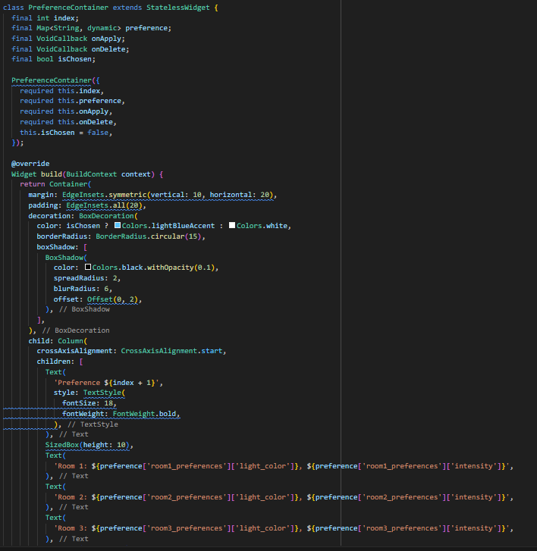

Preferences container

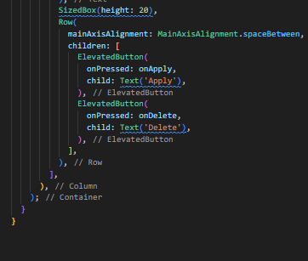

MQTT setup
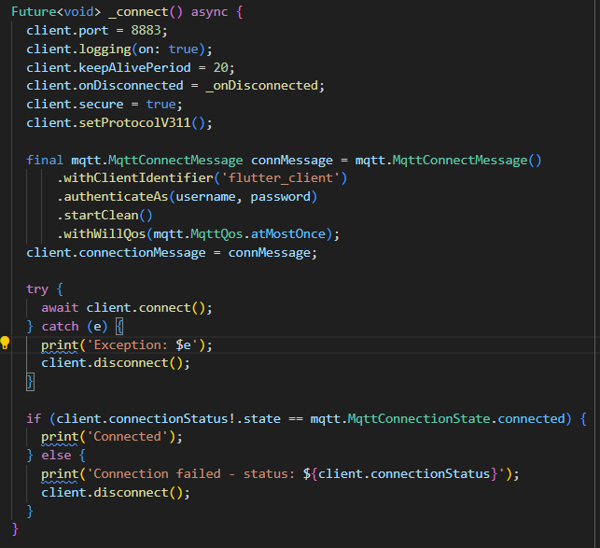

MQTT publishing

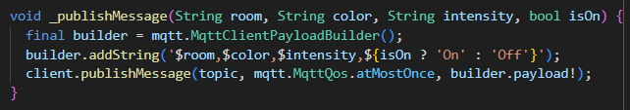
Fetch preference

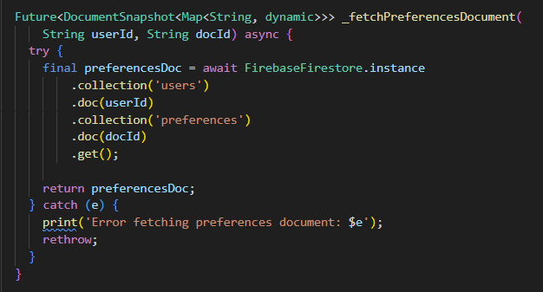

MQTT credentials

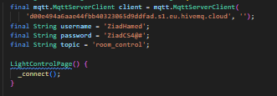

Reset password

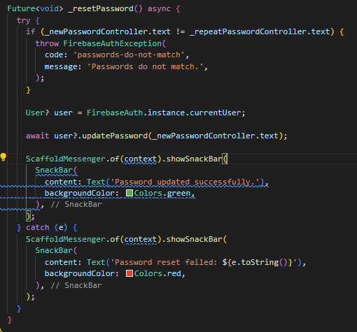

ON, OFF button handling

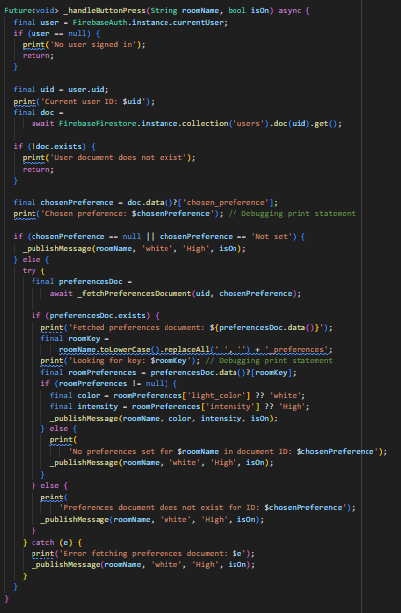

Add turn off times to firebase

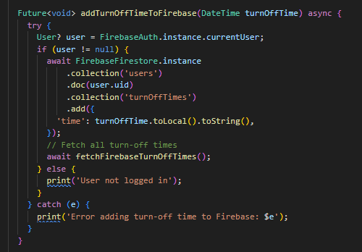

Fetch turn off times from firebase
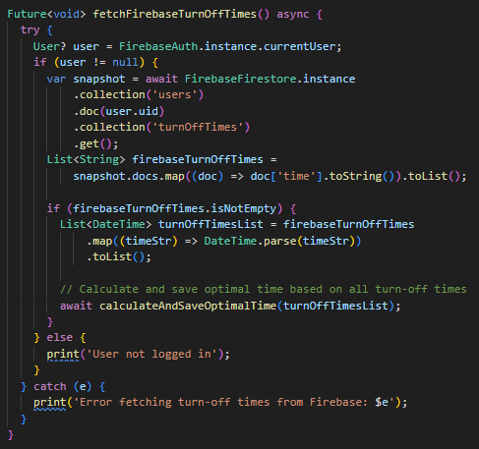
Calculate and save optimal time
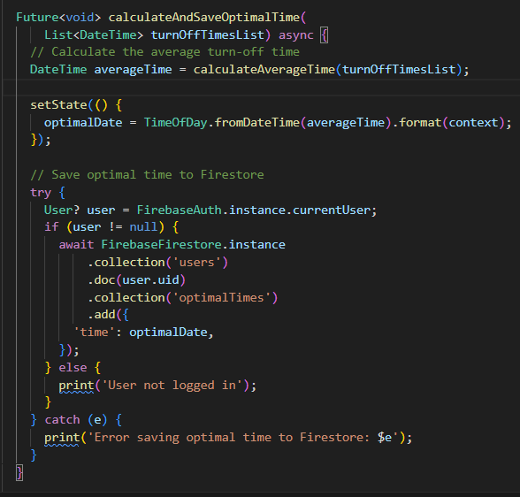
Pick time
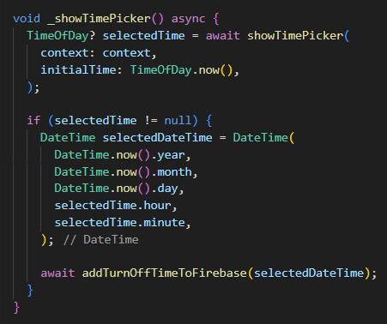
Submit rating

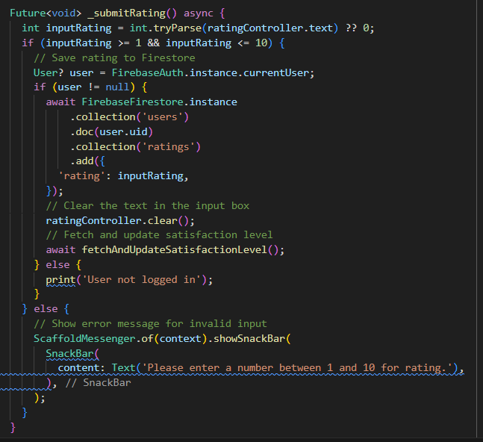

Fetch and update satisfaction level

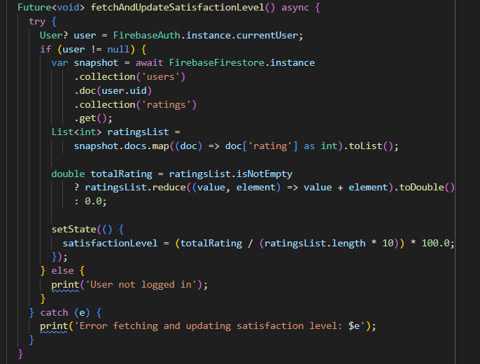

Sign up

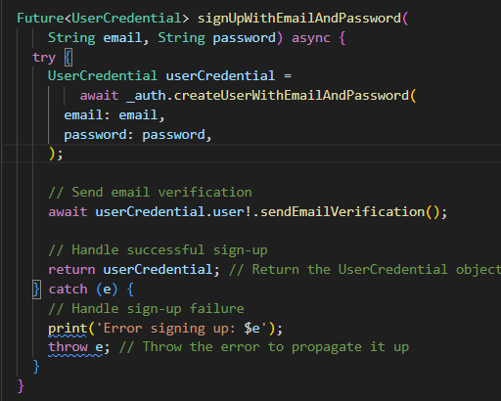

Sign in

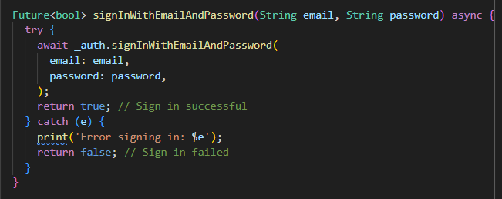

Sign out

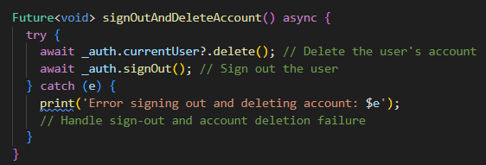

7.2.2 Python

Face recognition flask API
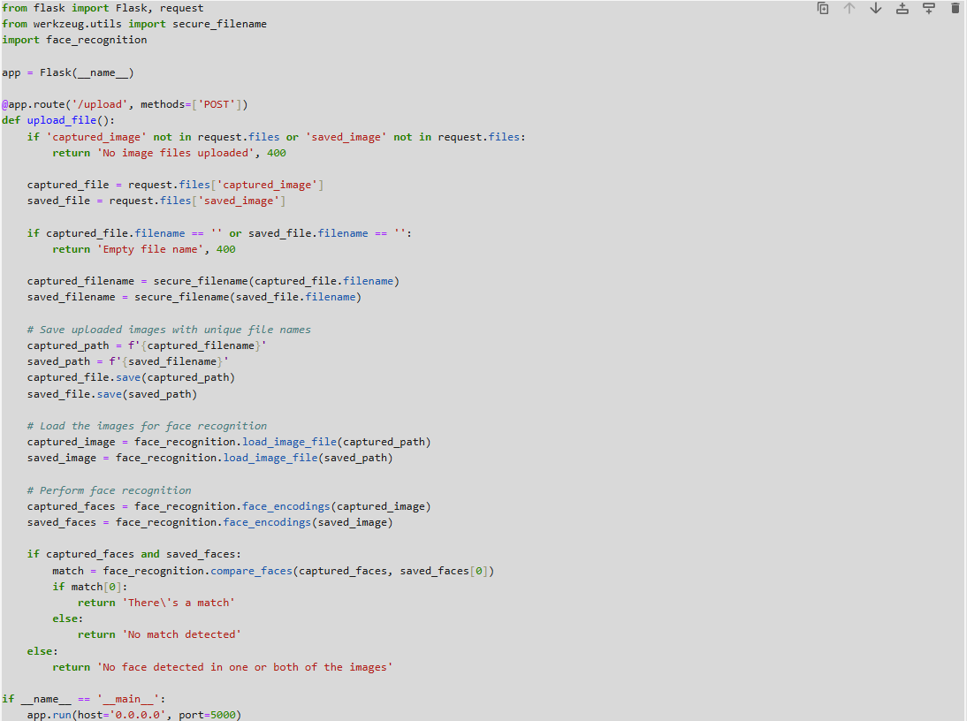

7.2.3 C

MQTT initialization
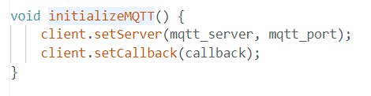
WIFI initialization
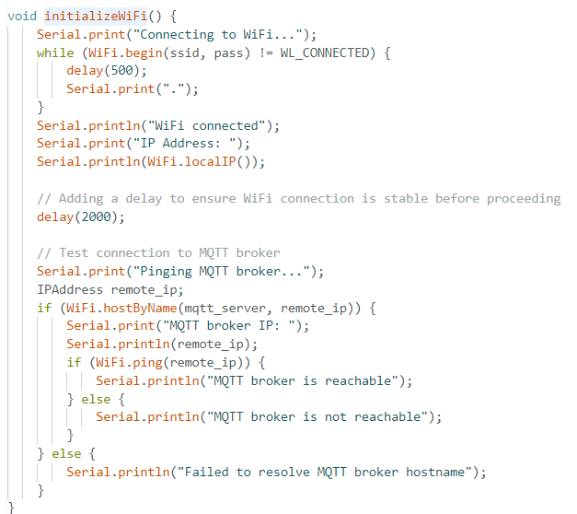
MQTT reconnection
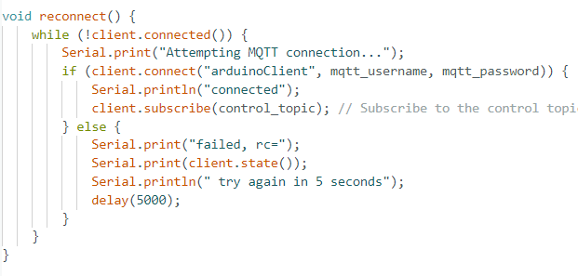
Temp & humidity publishing
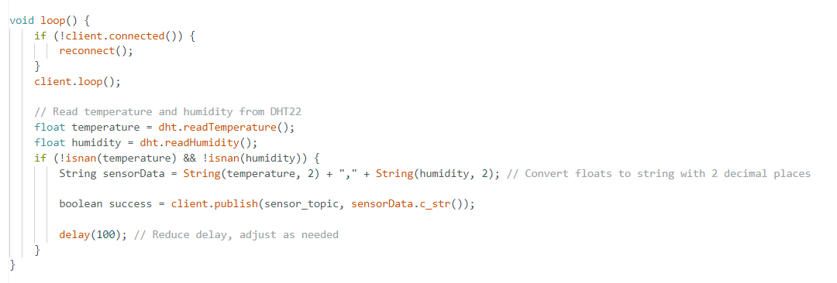

Receive message from topic “control-topic”
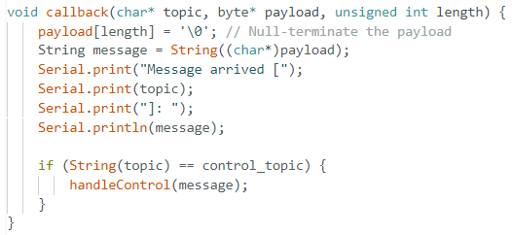

Light control
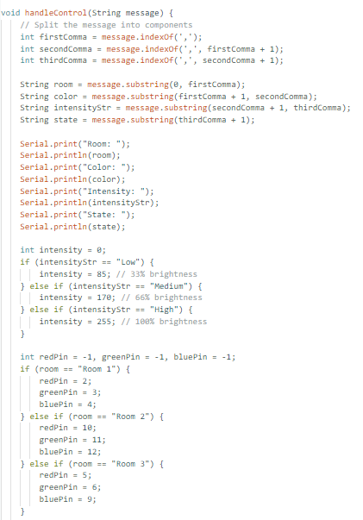

Light control
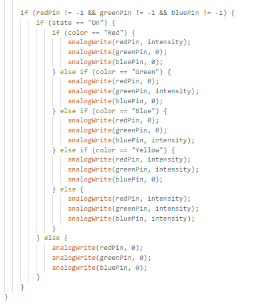

Chapter 8 Bibliography
1-Firebase Documentation
Title: Firebase Documentation
Publisher: Google
URL: https://firebase.google.com/docs
Description: Comprehensive guide and reference for integrating Firebase services, including authentication, real-time database, and cloud functions, into mobile and web applications.

2-Flutter Documentation
Title: Flutter Documentation
Publisher: Google
URL: https://flutter.dev/docs
Description: Official documentation for Flutter, providing detailed information on developing cross-platform mobile applications with Flutter, including widgets, navigation, and state management.

3-Arduino Nano 33 IoT Documentation
Title: Arduino Nano 33 IoT Documentation
Publisher: Arduino
URL: https://www.arduino.cc/en/Guide/NANO33IoT
Description: Detailed guide on setting up and using the Arduino Nano 33 IoT, including pinout, specifications, and sample projects.

4-DHT22 Sensor Datasheet
Title: DHT22 (AM2302) Temperature and Humidity Sensor Datasheet
Publisher: Aosong Electronics Co., Ltd
URL: https://www.sparkfun.com/datasheets/Sensors/Temperature/DHT22.pdf
Description: Technical datasheet for the DHT22 sensor, providing detailed specifications, wiring diagrams, and usage instructions.

5-IEEE 829 Standard for Software and System Test Documentation
Title: IEEE 829-2008 - IEEE Standard for Software and System Test Documentation
Publisher: IEEE
URL: https://standards.ieee.org/standard/829-2008.html
Description: Standard providing guidelines for creating and maintaining software and system test documentation, including test plans, test cases, and test reports.

6-The Internet of Things: Key Applications and Protocols
Title: The Internet of Things: Key Applications and Protocols
Authors: Olivier Harsen, David Boswarthick, Omar Elloumi
Publisher: Wiley
Year: 2012
Description: Book discussing the applications, protocols, and challenges of the Internet of Things (IoT), with a focus on smart home technologies and devices.

7-Flutter Projects
Title: Flutter Projects: A practical, project-based guide to building real-world cross-platform mobile applications and games
Author: Simone Alessandria
Publisher: Packt Publishing
Year: 2020
Description: Practical guide with projects demonstrating how to build cross-platform mobile applications using Flutter, covering various features and functionalities.

8-Human-Computer Interaction: An Empirical Research Perspective
Title: Human-Computer Interaction: An Empirical Research Perspective
Author: I. Scott MacKenzie
Publisher: Morgan Kaufmann
Year: 2013
Description: Book discussing the principles and methodologies of human-computer interaction (HCI), relevant for designing user-friendly smart home interfaces.

9-Designing the Internet of Things
Title: Designing the Internet of Things
Authors: Adrian McEwen, Hakim Cassimally
Publisher: Wiley
Year: 2013
Description: Comprehensive guide on designing IoT systems, covering hardware, software, and network considerations for creating interconnected smart devices.

10-Home Automation: Projects with Arduino, Raspberry Pi, and ESP8266
Title: Home Automation: Projects with Arduino, Raspberry Pi, and ESP8266
Authors: Marco Schwartz
Publisher: Elektor
Year: 2016
Description: Practical guide featuring projects for home automation using Arduino, Raspberry Pi, and ESP8266, with step-by-step instructions and code examples.

11-Real-Time Embedded Systems: Design Principles and Engineering Practices
Title: Real-Time Embedded Systems: Design Principles and Engineering Practices
Authors: Xiaocong Fan
Publisher: Newnes
Year: 2015
Description: Comprehensive guide on designing and developing real-time embedded systems, covering hardware-software integration, real-time operating systems, and practical applications.

Senior Project Summary Report

Project Title | Smart Home Application
Supervisor(s) | Dr/ Emad Raouf
Team Members | Mohamed Sewilam 20109043  Mohamed Tarek 20102053  Abdallah Mohamed 20109594  Ziad Hamed 20100373  Abdelrahman Kamal 20100101
Deliverables | Smart Home Management System App:  - A fully functional mobile application built with Flutter, featuring secure user authentication, energy-saving functionalities, environment monitoring, lighting control, and user preferences management.  Backend Services:  - Firebase integration for authentication, data storage, real-time database operations.  Hardware Components:  - Integration and configuration of Arduino Nano 33 IoT and DHT22 sensor for real-time environmental data collection (temperature and humidity).  Documentation:  - Technical documentation including system architecture, codebase explanation, and API references.  - Project report outlining project objectives, methodology, results, and future work.  Testing Reports:  - Detailed test plans, test cases, and testing reports following the IEEE 829 format, covering all aspects of the application and hardware integration.  Source Code:  - Complete source code for the mobile application, backend services, and hardware interface scripts, hosted on a version control system like GitHub.
Team Organization | Project Manager:  Name: Abdelrahman Kamal  Role: Oversees project progress, coordinates between team members, manages timelines, and ensures project goals are met.  Contributions: Project planning, resource allocation, progress tracking, and stakeholder communication.  Mobile Developers:  Name: Ziad Hmed, Abdallah Mohamed & Mohamed Tarek  Role: Focuses on developing the Flutter application, ensuring a seamless user experience.  Contributions: Implemented user interfaces, navigation, and core functionalities of the app.  Backend Developers:  Name: Ziad Hamed & Mohamed Sewilam  Role: Develops and maintains backend services, ensuring secure and efficient data handling.  Contributions: Firebase setup, cloud functions, and real-time database operations.  Hardware Specialists:  Name: Mohamed Sewilam & Abdallah Mohamed  Role: Integrates hardware components with the software system, ensuring reliable data collection.  Contributions: Configuration of Arduino Nano 33 IoT, interfacing with the DHT22 sensor, and data transmission to the app.  Tester/QA Engineers:  Name: Mohamed Tarek & Abdelrahman Kamal  Role: Conducts thorough testing of both software and hardware components, ensuring a bug-free user experience.  Contributions: Developed and executed test plans, documented test cases, and managed defect tracking.
Ethical Considerations | Data Privacy: Ensuring that all user data, including personal information and facial recognition data, is securely stored and processed in compliance with data protection regulations.  Security: Implementing robust security measures to protect against unauthorized access and data breaches.  Environmental Impact: Promoting sustainable living practices through energy-saving features, contributing to environmental conservation.  User Safety: Ensuring that hardware components are safely installed and used, minimizing the risk of electrical hazards or malfunctions.
Social Empact | Energy Efficiency: By providing tools to optimize energy consumption, the project promotes sustainable living and reduces utility costs for users.  Comfort and Convenience: Enhancing the quality of life for users through automated home management, personalized settings, and real-time environmental monitoring.  Awareness and Education: Raising awareness about energy conservation and smart home technologies, encouraging users to adopt sustainable practices.  Accessibility: Making smart home technologies accessible to a broader audience, enhancing inclusivity and quality of life.
Professional Responsibility | Adherence to Standards: Following industry standards and best practices in software development, testing, and hardware integration to ensure a high-quality, reliable product.  Continuous Improvement: Engaging in continuous learning and improvement, seeking feedback, and iterating on the project to address any issues and incorporate new advancements.  Transparency: Maintaining transparency with stakeholders, providing regular updates on project progress, challenges, and solutions.  Accountability: Taking responsibility for the project's outcomes, ensuring that all deliverables meet the expected quality and ethical standards.  Ethical Conduct: Upholding ethical conduct in all aspects of the project, from data privacy to user interactions, ensuring trust and credibility.

Supervisor Name | Signature

